TM Forum Open APIs
Conformance Certification

Company Name: Amdocs
TM Forum Open API Name: TMF629 Customer Management
TM Forum Open API Release Version: R19.0/4.0

Report Date: 31 August, 2020

- What Product or Solution does your API support?

CES20 is Amdocs’ market-leading customer experience cloud-native suite designed to accelerate service providers’ journey to the cloud and power the move from legacy systems to a leading microservices-based suite. Amdocs’ CES20 is the only fully-cloud-native, 5G-ready, pre-integrated BSS-OSS suite, enabling service providers to go from concept/code to monetization/production in minutes.
Amdocs’ CES20 includes:

1. DigitalONE for multichannel commerce and care
2. CatalogONE for flexible, marketing-driven product packaging
3. RevenueONE for real-time monetization
4. Service & Network Automation – this solution includes end-to-end service lifecycle management capabilities covering service design, service orchestration and inventory management

- Overview of Certified API

Aligned with TM Forum’s open API framework, CES20 offers a continuous integration/continuous delivery (CI/CD) environment built on Amdocs’ cloud-agnostic Microservices 360 (MS360) infrastructure platform. This helps service providers drive operational change and bring the business the needed agility and IT velocity to deliver results.

- Architectural View

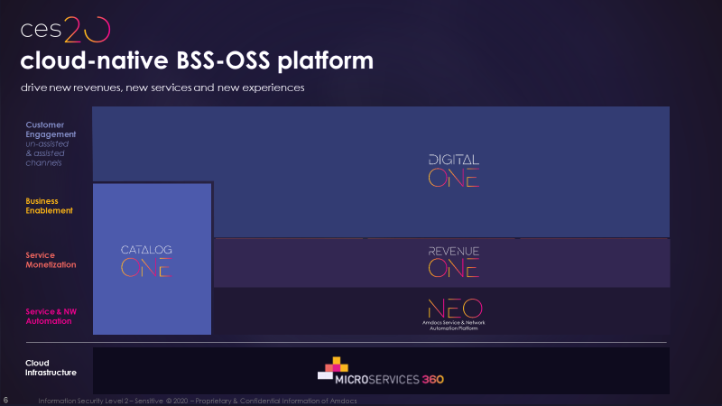
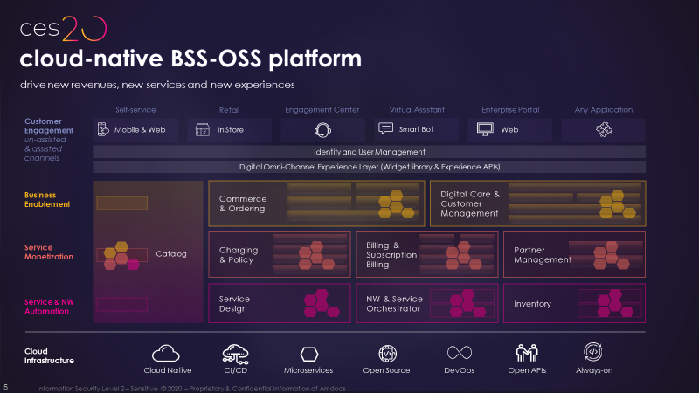

DigitalONE is a telco-specific cloud-native open and modular digital enablement platform for customer end-to-end care, commerce and order management journeys, spanning the entire order lifecycle, serving all care-billing-commerce needs with a single solution. It provides communications and media companies with the business agility to offer new digital experiences of the type and at the pace of native internet companies across ANY channel application, assisted or unassisted, existing or future ones; supports ANY line of business, service and bundle including third party - to ANY customer, existing or new, consumer or enterprise and it fits any existing legacy BSS that the operator is using.
The DigitalONE platform is cloud-native, so it can scale on-demand to support changing activity levels. Furthermore, it incorporates open-source technologies and exposes application programming interfaces (APIs) that align with TM Forum standards, allowing easy addition of new capabilities and their re-use across any engagement channel, line of business and technology.

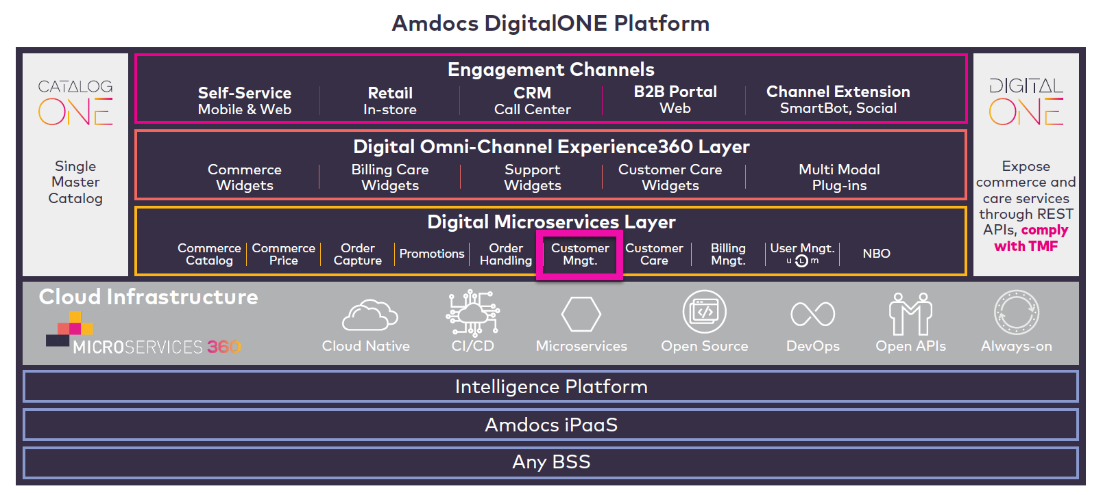

- Test Results

