**TM Forum Open APIs**

**Conformance Certification**

*Company Name:* ***Tecnotree***

*TM Forum Open API Name:* ***Account Management API – TMF666***

*TM Forum Open API Release Version:* ***R19.0.1 / v4.0.0***

**Report Date: 10th November 2020**

1. **What Product or Solution does your API support?**

There is a broad agreement in the Communication Services Provider (CSP) community that one of the largest contributors to customer retention, and thereby solid revenue, is the customer experience. At the same time, research has identified that this hallmark of greater customer experience can be directly linked to efficiency in Billing. This view is derived from the simple fact that a bill is the most visible communication between a customer and the CSP. Even today a large majority of customer care interactions continue to revolve around issues emanating out of incorrect billing.

Given the importance of accurate billing, one of the first priorities towards an improved customer experience is to address the pressing needs around seemingly mundane issues like billing operations and revenue assurance, thereby removing the source of customer dissatisfaction which is stemming customer churn to avoid reduction in revenue.

The situation is soon becoming complicated for the CSPs facing a double-sided threat endangering their quest for new revenue. On one hand, they are faced with the visible dangers of being non-competitive due to an inability to quickly monetize new services. This coupled with the more traditional challenges in billing operations effectiveness is casting serious doubts on their ability to create an outstanding customer experience which in extreme cases will compromise their ability to retain customers. The first of these challenges is directly linked to the limitations of many legacy billing solutions, slowing down the introduction of new offerings and hence immediate revenue growth. The second of these challenges is forcing CSPs to have another look at new ways to consolidate and manage their core billing operations in order to keep operational costs down.

A careful analysis around the above demands clearly presents an array of opportunities revolving around the support of multiple services, efficient charging and billing, bill convergence and flexible payment options. By carefully balancing the operational efficiencies with new business model introduction a CSP can quickly tap into new revenue streams while all the while ensuring integrity of the related business processes. Tecnotree **Digital Convergent Billing System (DCBS)** is a unified revenue management solution that can help to consolidate the various business assets and transform them into reusable components for creating new business models to address the growing consumer appetite for new services. Designed to address all the revenue management needs of a modern CSP, Tecnotree Digital Convergent Billing System provides an all-in-one convergent platform to manage traditional as well as next-gen services, it helps CSPs to maintain a holistic view of all services subscribed and used by the customers in order to create novel ways for service monetization.

Tecnotree Digital Convergent Billing System allows CSPs to conveniently manage a mix of multiple services from themselves and partners alike. By providing a real-time charging capability Tecnotree Digital Convergent Billing System ensures accurate billing every time while supporting a broad range of flexible payment options. By monetizing all customers across business lines and types of service on a single platform the CSPs can rationalize the often-inefficient legacy interfaces previously in place across various network elements, significantly reducing the possibility of revenue leakage and resulting bad debts. All the above put together allows CSPs to concentrate on running a business rather than worrying about maintaining their billing infrastructure. Further customer experience is improved by allowing the choice of a single bill for all services, along with access to accurate real-time information over self-care.

1. **Overview of Certified API**

The Account Management API provides standardized mechanism for the management of billing and settlement accounts, as well as for financial accounting (account receivable) either in B2B or B2B2C contexts and is managed by Tecnotree’ s Digital Convergent Billing System (DCBS).

Account Management API allows creation, update and retrieval of account information either in a B2B2C relationship context or in a B2B context.

It also allows creation and query of bill items allowing partners or B2B customer to check their invoice.

Product Ordering API provides a standardized mechanism for placing a product order with all of the necessary order parameters. The API consists of a simple set of operations that interact with CRM/Order Negotiation systems in a consistent manner. A product order is created based on a product offer that is defined in a catalog. The product offer identifies the product or set of products that are available to a customer, and includes characteristics such as pricing, product options and is managed by the Tecnotree’ s Digital Order Manager (DOM).

Some of the Actual Operations supported over this API are:

* Operations on Party Account
  + - List party accounts
    - Retrieve party account
    - Create party account
    - Patch party account
    - Delete party account
* Operations on Billing Account
  + - List billing accounts
    - Retrieve billing account
    - Create billing account
    - Patch billing account
    - Delete billing account
* Operations on Settlement Account
  + - List settlement accounts
    - Retrieve settlement account
    - Create settlement account
    - Patch settlement account
    - Delete settlement account
* Operations on Financial Account
  + - List financial accounts
    - Retrieve financial account
    - Create financial account
    - Patch financial account
    - Delete financial account
* Operations on Billing Cycle Specification
  + - List billing cycle specifications
    - Retrieve billing cycle specification
    - Create billing cycle specification
    - Patch billing cycle specification
    - Delete billing cycle specification
* Operations on Bill Format
  + - List bill formats
    - Retrieve bill format
    - Create bill format
    - Patch bill format
    - Delete bill format
* Operations on Bill Presentation Media
  + - List bill presentation medias
    - Retrieve bill presentation media
    - Create bill presentation media
    - Patch bill presentation media
    - Delete bill presentation media

1. **Architectural View**

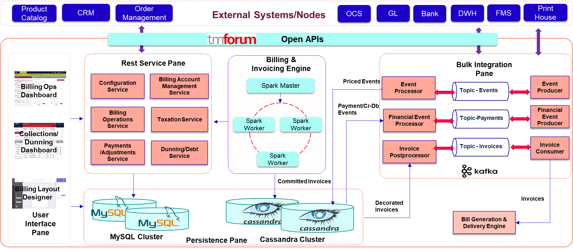

1. **Test Results**

