**TM Forum Open APIs**

**Conformance Certification**

*Company Name:* ***Tecnotree***

*TM Forum Open API Name:* ***Product Ordering API – TMF622***

*TM Forum Open API Release Version:* ***R19.0.1 / v4.0.0***

**Report Date: 2nd November 2020**

1. **What Product or Solution does your API support?**

It is no secret that economy is turning digital, with the advent of mobile telephony and widespread deployment of the internet. The industry as it today stands disrupted by the increasing role of third-party Digital Services providers. Digital Services has gained popularity with Subscribers for simplicity; the choice to pick and match services, purchase and activate them on the fly without having to wait in queue, anywhere, using any device.

As a result, Communication Service Providers (CSP) are faced with challenges which impacts their revenue streams. However, this also presents CSPs with an opportunity to play an important role in the advancement of digital transformation of various verticals. The established customer and billing relationships, along with large amount of behavioral data, are key advantages for CSPs to widen their presence across the Digital Services landscape. In today’s highly interconnected digital ecosystem, it is vital for CSPs to reinvent their business model and provide new services for the digital age; such as Mobile Money Transactions (MMT), Digital Subscription, Internet of Things (IoT) and Big Data, referred to as Digital Services apart from just legacy services. Digital Services, contrary to legacy services where CSPs control end to end delivery, are delivered by CSPs’ in tandem with partners.

As understood above, for CSP’s to stay competitive they will need to partner to offer myriads of Internet services along with legacy services. However, to ensure that customer experience is not compromised, it is paramount for CSP’s to find ways to seamlessly activate and deliver digital services to customers in real-time, with zero intervention. However, these changes are causing fulfilment to catch up/unable to support complex needs causing disruption in service delivery ecosystem

The above demands present an array of opportunities in the fulfilment space. By carefully balancing the operational efficiencies with new offering introduction a CSP can quickly tap into new revenue streams while ensuring legacy business processes.

Tecnotree Digital Order Management (DOM) System is powered by centralized service catalog, which is cloud compliant, powered by Microservices based architecture is a comprehensive fulfillment tool that enables CSP to address the growing consumer appetite for services across the spectrum.

With Tecnotree Digital Order Management, CSP can now seamlessly manage both Digital and Legacy Services and reduce order lifecycle to activate from weeks to days, with effective automation. Digital Order Management provides CSP with **Service Order Management (SOM)** and **Resource Order Management (ROM)** capabilities to enable fulfilment as prescribed by TM Forum.

Digital Order Management provides key business enablers, ranging from Service Abstraction of all Resources in the CSP ecosystem to Tools to Model and Realize Offering and dependencies, Manage Configurable Workflows to Analyze & Optimize Orders; to manage fulfilment of customer’s requests into fully enabled products & services enabling Monetization for CSP.

1. **Overview of Certified API**

Product Ordering API provides a standardized mechanism for placing a product order with all of the necessary order parameters. The API consists of a simple set of operations that interact with CRM/Order Negotiation systems in a consistent manner. A product order is created based on a product offer that is defined in a catalog. The product offer identifies the product or set of products that are available to a customer, and includes characteristics such as pricing, product options and is managed by the Tecnotree’ s Digital Order Manager (DOM).

Some of the Actual Operations supported over this API are

…on Product Order:

* Retrieval of a product order or a collection of product orders depending on filter criteria
* Partial update of a product order (including updating rules)
* Creation of a product order (including default values and creation rules)
* Deletion of product order (for administration purposes)
* Notification of events on product order
  + Product Order creation
  + Product Order removal
  + Product Order state change
  + Product Order value change used to notify that any data in an order has just changed
  + Product Order information required used to notify that some data in the order need to be filled / are missing

…on Cancel Product order:

* Retrieval of a product order cancellation request or a collection of product order cancellation requests depending on filter criteria
* Creation of a product order cancel request
* Notification of events on product order
  + Cancel Product Order creation
  + Cancel Product Order state change
  + Order information required used to notify that some data in the cancel product order need to be filled / are missing

1. **Architectural View**

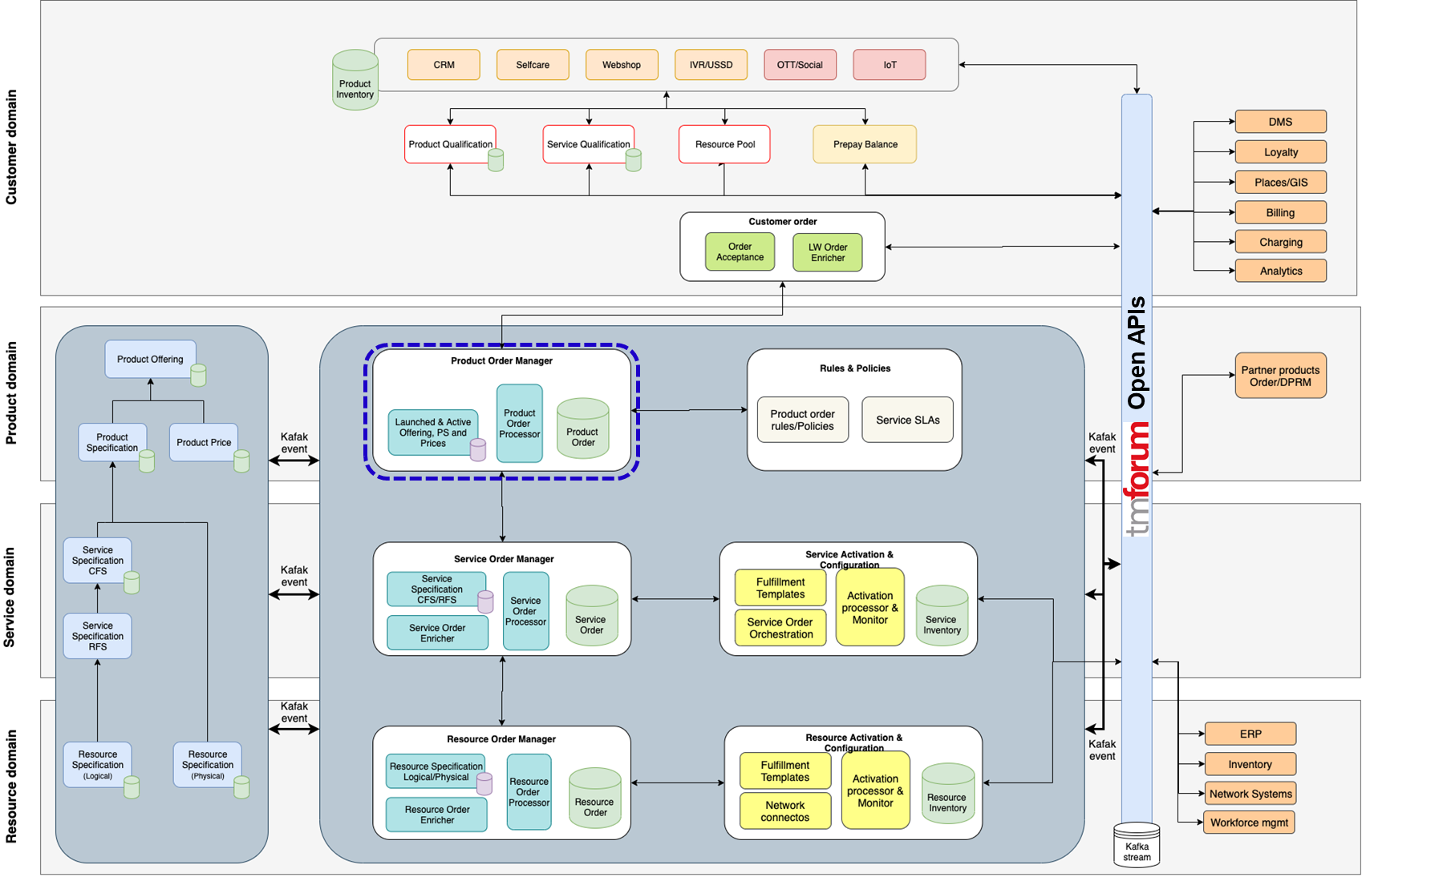

1. **Test Results**

