**TM Forum Open APIs**

**Conformance Certification**

*Company Name:* ***Tecnotree***

*TM Forum Open API Name:* ***Quote Management API – TMF648***

*TM Forum Open API Release Version:* ***R19.0.1/v4.0.0***

**Report Date: 2nd November 2020**

1. **What Product or Solution does your API support?**

Market opportunities and evolving customer needs have encouraged Communication Service Providers (CSP) in broadening their operations and managing multiple lines of businesses (LOBs). Such expansions have compounded the complexity of their products and services and resulted into multiple OSS and BSS systems in their operational landscapes. At the same time, there is an intense pressure of enhancing customer experience and declining traditional revenue streams.

Tecnotree Digital Catalog Manager (DCM) is a central repository of products that spans across multiple lines of businesses. DCM plays a vital role in CSP’s environment by providing the integration of products and resources across the business and operational support systems (B/OSS), thus contributing to both the current and emerging market opportunities by helping them surge ahead of the competition.

Tecnotree Digital Catalog Manager (DCM) helps unify product management and streamlines the process of product creation and launch. It provides CSPs the flexibility of phasing out legacy systems and migrating to strategic systems to meet their product management challenges. This comprehensive and detailed approach adopted by DCM is one of the core reasons for it becoming the tool that bolsters the CSPs’ business and operational strategy.

1. **Overview of Certified API**

Quote Management is managed by the Tecnotree’ s Digital Catalog Manager (DCM). DCM provides Open APIs/REST Based APIs in line with TM Forum defined specification that allows management of the entire lifecycle of the Service catalog elements. The Quote Management API is used for providing a standardized mechanism for placing a customer quote with all of the necessary parameters.

Some of the Actual Operations supported over this API are

* Retrieval of a customer quote or a collection of customer quote depending on filter criteria
* Partial update of a customer quote (including updating rules)
* Creation of a customer quote (including versioning, default values and creation rules)
* Deletion of customer quote (for administration purposes)
* Notification of events on quote o Quote creation
  + Quote removal
  + Quote state change
  + Quote value change used to notify that any data in an quote has just changed
  + Quote information required used to notify that some data in the quote need to be filled / are missing
  + Quote is a pending state waiting approval (for the whole quote or only for quote item)
  + quote is accepted by the customer but there is a least one agreement to be signed

1. **Architectural View**

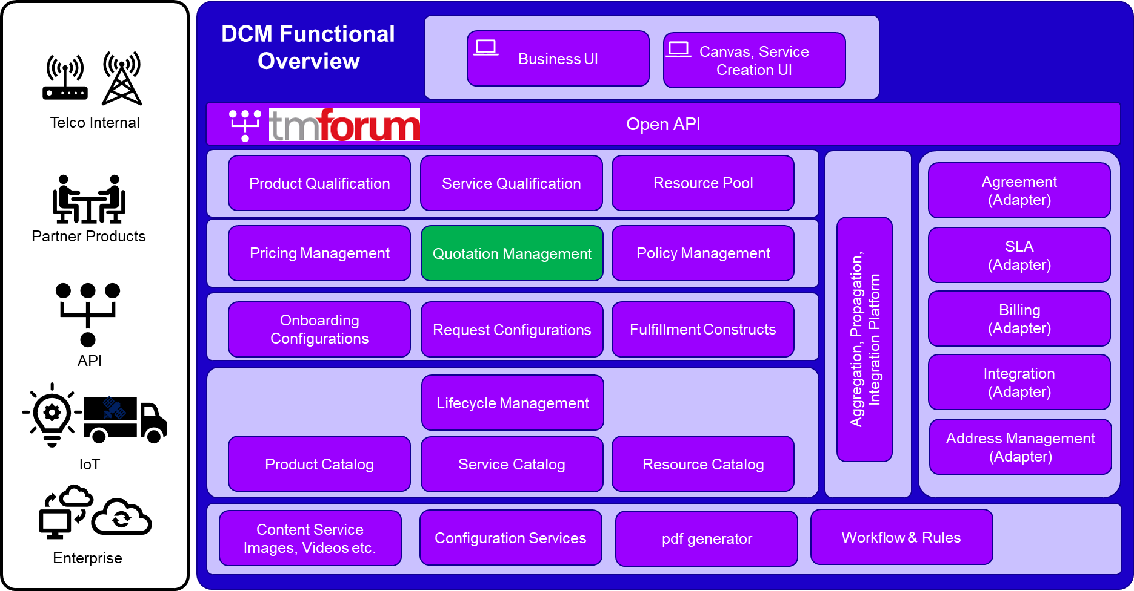

1. **Test Results**

