35

**TM Forum Open APIs**

**Conformance Certification**

*Company Name:* ***Comviva Technologies Limited***

*TM Forum Open API Name:* ***TMF635 – Usage Management API***

*TM Forum Open API Release Version:* ***R20.5.0 /v4.0.0***

**Report Date: 19/02/2021**

1. **What Product or Solution does your API support?**

Comviva’s BSS suite is a comprehensive and focused business support system that handles an operator's entire set-up, allowing more efficient management of the operator resources, streamlining operational activities and delivering lifetime support to the operator’s network and subscriber base. Utilizing common unified interface across multiple operational activities, the service provider is able to manage the complete mobile subscriber lifecycle. The single, consolidated view of operations provided by Comviva’s BSS suite enables operators to appropriately prioritize subscriber demands and meet subscriber expectations. Via its centralized repository and flexible workflows, Comviva’s BSS suite effectively handles all manner of queries, enhancing customer services, improving customer satisfaction and ultimately enabling a more focused marketing strategy.

Comviva’s BSS suite is an end-to-end Business Support solution, with ability to integrate with the rating and credit management platform including Intelligent Networks, Service Nodes and Hot Billing solutions. It is designed to provide the capability to leverage creative marketing programs to the full, while maximizing the effectiveness of Customer Care. It is designed as a modular system so it will grow alongside each operators expanding service portfolio and support an increasing subscriber base.

Comviva’s BSS suite can be rapidly deployed at and offers an excellent range of features. Some of the basic dimensions that have been taken into account while designing Comviva’s BSS suite include:

* Scalability of software to support the growth plan of service providers
* Ability to interface seamlessly with existing and new applications, protecting investment
* Minimization of revenue loss
* Rapid deployment
* Ability to cater to a wide spectrum of communication
* Easy to learn and faster to use to cut training costs.

Comviva’s BSS suite solution is a leading edge, Provisioning & Customer Care solution that integrates critical business processes and workflows of prepaid operations. Comviva’s BSS suite empowers the Customer Care personnel with the ability to address customer problems, queries and requests effectively and efficiently

1. **Overview of Certified API**

The Usage API provides a standardized mechanism for usage management such as the creation, update, and retrieval of usages. A usage is an occurrence of employing a Product, Service or Resource for its intended purpose which is of interest to the business and can have charges applied to it.

Comviva CRM supports rated CDR (Call Detail records) of customers by service provider to provide rated usages to a partner for their consumptions.

A CDR follows a simple lifecycle which is presented later for illustrative purposes, defining such aspects as whether it is rated, rerated or billed. The main attributes are its id, usageDate, usageType(Voice, Data , SMS), it’s usageType related UsageSpecification(country code , A party ,B party ), characteristics (name/value pairs), status, related Parties and rating related information (such as date, amount, taxes).

* + - **Usage Operations**
* List Usages
  + This operation list usage entities
* Retrieve Usage
  + This operation retrieves a usage entity
* Create Usage
  + This operation creates a usage entity
* Patch Usage
  + This operation update a usage entity
* Delete Usage
  + This operation delete a usage entity
    - **Usage Specification Operations**
* List Usage Specifications
  + This operation list usage specification entities
* Retrieve Usage Specification
  + This operation retrieves a usage specification entity
* Create Usage Specification
  + This operation create a usage specification entity
* Patch Usage Specification
  + This operation update a usage specification entity
* Delete Usage Specification
  + This operation delete a usage specification entity

1. **Architectural View**

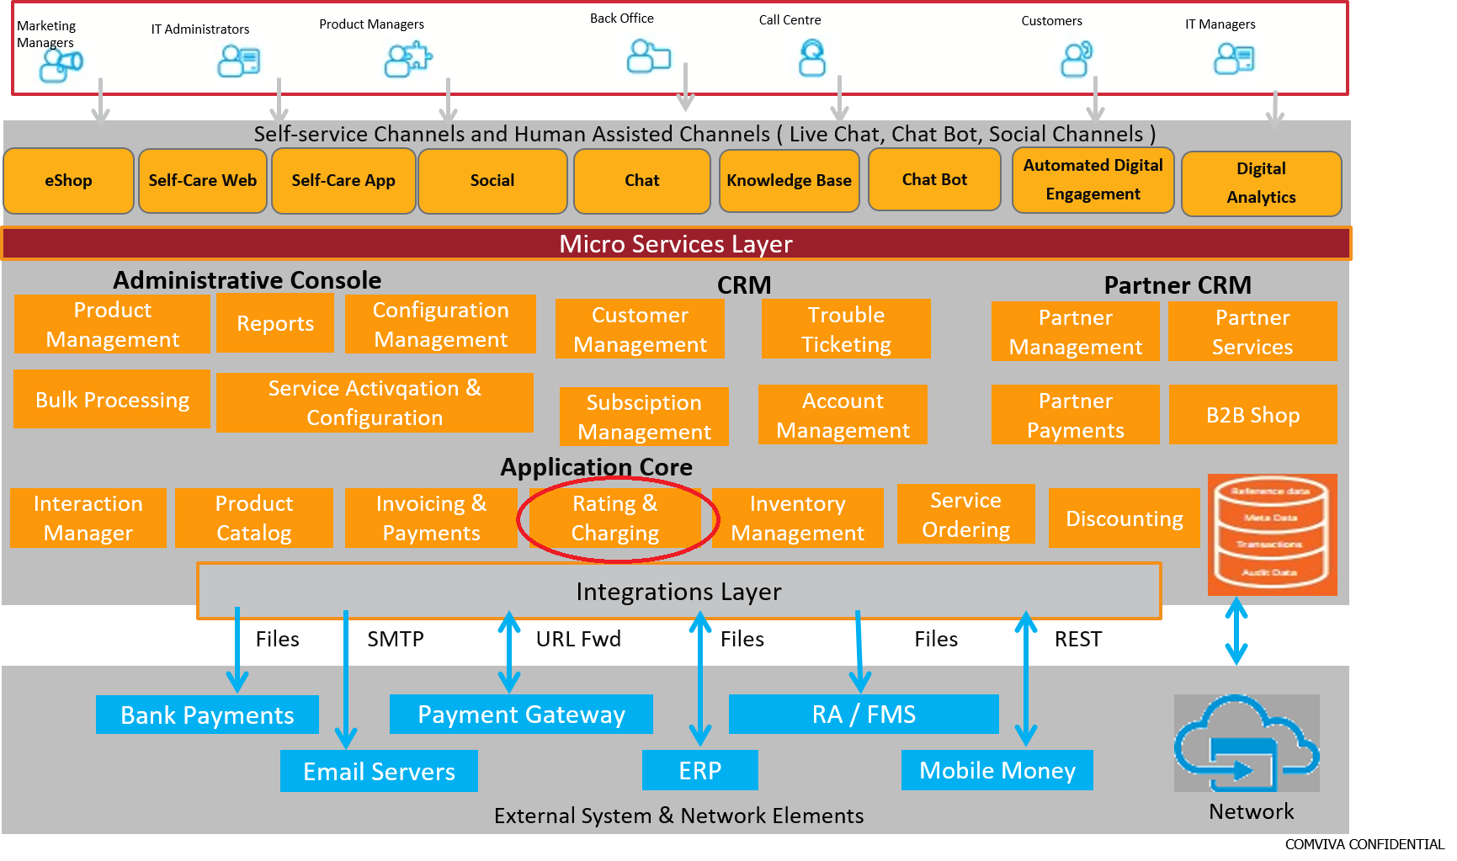

1. **Test Results**

