**TM Forum Open APIs**

**Conformance Certification**

*Company Name:* ***Huawei Technologies Co. Ltd***

*TM Forum Open API Name:* ***TMF620 Product Catalog Management API***

*TM Forum Open API Release Version:* ***R19.0.1 /v4.0.0***

**Report Date: 13-08-2020**

1. **What Product or Solution does your API support?**

The Huawei BSS provides digital service monetization engine for Telco, accelerate your business innovation, faster TTM via decoupled and layered architecture, service agility with a real-time, open end to end charging & billing capabilities solution. Leading operators are on the way to 5G commercialization.

A key component of the solution is United Product Catalog. The Product Catalog API provides an interaction interface with Product Catalog systems/the third-parties.

1. **Overview of Certified API**

Product Catalog API is one of Catalog Management API Family. Product Catalog API goal is to provide a catalog of products. It includes the following 5 resources and operations:

1. Catalog resource is a collection of product offerings.
2. Category resource is used to group product offerings.
3. Product Offering resource represents entities that are orderable from the provider of the catalog, this resource includes pricing information
4. Product Offering Price resource is based on both the basic cost to develop and produce products and the enterprises policy on revenue targets.
5. Product Specification resource is a detailed description of a tangible or intangible object made available externally in the form of a product offering to customers or other parties.

Operations of these 5 resources are as the below picture:

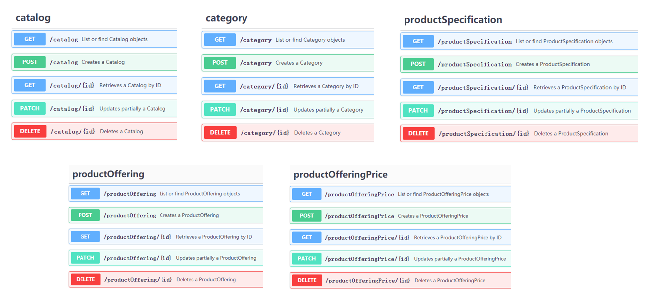

1. **Architectural View**

The following diagram shows a functional architecture view of Huawei BSS:

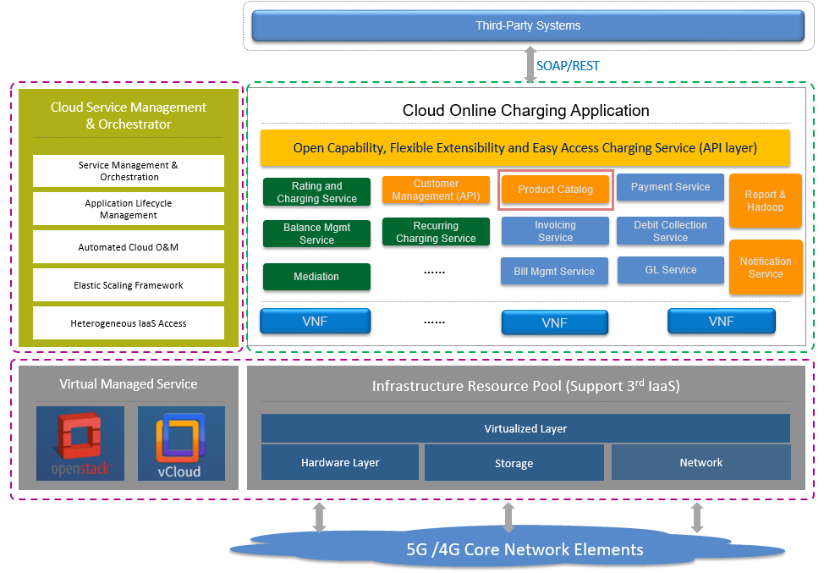

1. **Test Results**

