**TM Forum Open APIs**

**Conformance Certification**

*Company Name:* ***Huawei Technologies Co. Ltd***

*TM Forum Open API Name:* ***TMF 621 Trouble Ticket API***

*TM Forum Open API Release Version:* ***R19.0.1 /v4.0.0***

**Report Date: 16th of December, 2020**

1. **What Product or Solution does your API support?**

Huawei BSS is meant to support customer-related business process for Telco, accelerate the business innovation, faster TTM via advanced micro-service architecture, service agility with a real-time, open end-to-end commerce and subscription capabilities solution.

Around the globe, the leading operators are on the way to digital customer engagement with Huawei solution together.

**Trouble Ticket in Huawei BSS**

A key component of the solution is the Trouble Ticket module. It is part of “Service” of Huawei BSS. The external systems and the third-parties can access such capabilities via this exposed API.

1. **Overview of Certified API**

*Trouble Ticket* API is one of Common API Family as per *Open API Map* (GB992)

*Trouble Ticket* API provides a standardized client interface to Trouble Ticket Management Systems for creating, tracking and managing trouble tickets as a result of an issue or problem identified by a customer or another system.

*Trouble Ticketing* API manages trouble ticket resource:

- A trouble ticket represents a record, or an issue raised by requestor that need to be solved, used for reporting and managing the resolution of problems, incidents or request

- Main trouble ticket attributes are its description, severity, type, related dates (creation, expected resolution, resolution), state and related information (change reason and change date), related parties (originator, owner, reviser, etc.), related entities (product, product order, customer bill) and notes

According to *Trouble Ticket Conformance Profile* (TMF621B), the following table indicates which ones are mandatory and which ones are optional for Customer resource

|  |  |  |
| --- | --- | --- |
| Operation | Mandatory/Optional | Comments |
| GET | M | GET must be used to retrieve a representation of a resource |
| POST | M | POST must be used to create a new resource |
| PATCH | O | PATCH must be used to partially update a resource. |
| DELETE | O | DELETE must be used to remove a resource |

1. **Architectural View**

The following diagram shows a functional architecture view of Huawei BSS:

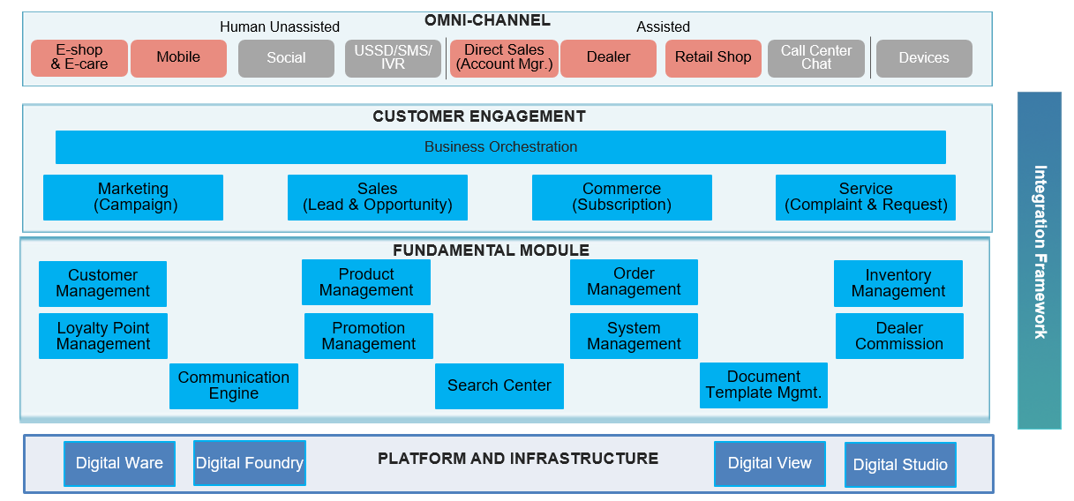

1. **Test Results**

