**TM Forum Open APIs**

**Conformance Certification**

*Company Name:* ***Huawei Technologies Co. Ltd***

*TM Forum Open API Name:* ***TMF 622 Product Ordering API***

*TM Forum Open API Release Version:* ***R19.0.1 /v4.0.0***

**Report Date: 10th of December, 2020**

1. **What Product or Solution does your API support?**

Huawei BSS is meant to support customer-related business process for Telco, accelerate the business innovation, faster TTM via advanced micro-service architecture, service agility with a real-time, open end-to-end commerce and subscription capabilities solution.

Around the globe, the leading operators are on the way to digital customer engagement with Huawei solution together.

**Product Ordering in Huawei BSS**

A key component of the solution is Order Management module. The Product Ordering API provides an interaction interface with this module and relevant functionalities of Huawei BSS. The external systems and the third-parties can access such capabilities via this exposed API.

1. **Overview of Certified API**

*Product Ordering* API is one of Customer API Family as per *Open API Map* (GB992) *Product Ordering* API provides a standardized mechanism for placing a product order with all of the necessary order parameters.

*Product Ordering* API manages product order resource:

• A Product Order is a type of order which can be used to place an order between a customer and a service provider or between a service provider and a partner and vice versa,

• Main Product Order attributes are its identifier, state, priority category (mass market, Enterprise, etc.) related dates (start, completion, etc.), related billing account, related parties and order items

• Main Order Items (aka order lines) attributes are the ordered offering and product characteristics with the related action to be performed (e.g. add or delete the products), state, location information for delivery.

According to *Product Ordering Conformance Profile* (TMF622B), the following table indicates which ones are mandatory and which ones are optional for Customer resource

|  |  |  |
| --- | --- | --- |
| Operation | Mandatory/Optional | Comments |
| GET | M | GET must be used to retrieve a representation of a resource |
| POST | M | POST must be used to create a new resource |
| PATCH | M (JSON-MERGE)  O (JSON-PATCH) | PATCH must be used to partially update a resource. Support of Json merge is mandatory, support of json-path is optional. |
| DELETE | M | DELETE must be used to remove a resource |

CancelProductOrder Operations

|  |  |  |
| --- | --- | --- |
| Operation | Mandatory/Optional | Comments |
| GET | M | GET must be used to retrieve a representation of a resource |
| POST | M | POST must be used to create a new resource |

1. **Architectural View**

The following diagram shows a functional architecture view of Huawei BSS:

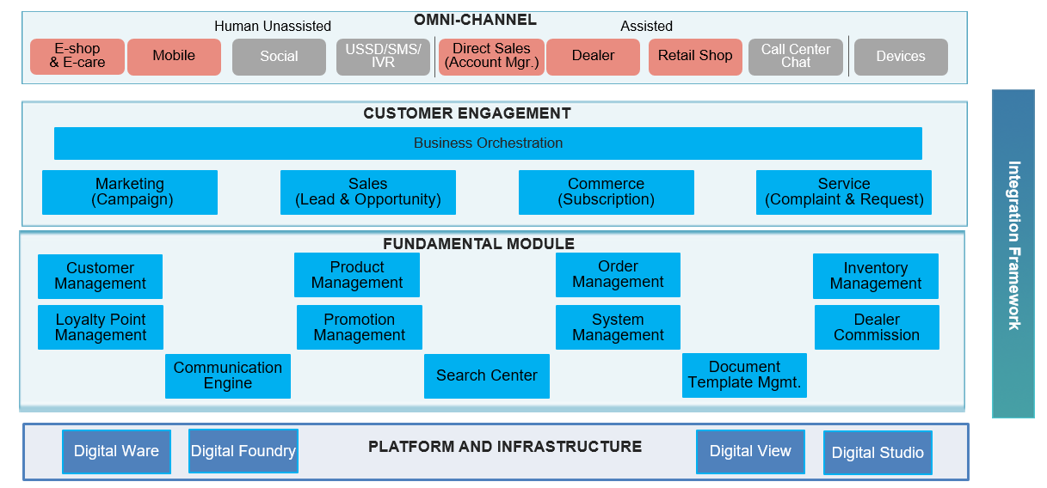

1. **Test Results**

