**TM Forum Open APIs**

**Conformance Certification**

*Company Name:* ***Huawei Technologies Co. Ltd***

*TM Forum Open API Name:* ***TMF629 Customer Management API***

*TM Forum Open API Release Version:* ***R19.0 /v4.0.1***

**Report Date: 23-12-2020**

1. **What Product or Solution does your API support?**

Huawei BSS is meant to support customer-related business process for Telco, accelerate the business innovation, faster TTM via advanced micro-service architecture, service agility with a real-time, open end-to-end commerce and subscription capabilities solution.

Around the globe, the leading operators are on the way to digital customer engagement with Huawei solution together.

A key component of the solution is Customer Management module. The Customer Management API provides an interaction interface with this module and relevant functionalities of Huawei BSS. The external systems and the third-parties can access such capabilities via this exposed API.

1. **Overview of Certified API**

Customer Management API is one of Customer API Family as per *Open API Map* (GB992) Customer Management API provides a standardized mechanism for customer management such as creation, update, retrieval, deletion and notification of events.

Customer management API manages the following data resources:

***Customer***

* Customer represents a person or organization that buys products and services from the enterprise or receives free offers or services. Customers can also be other service providers who resell the enterprises products, other service providers that lease the enterprise's resources for utilization by the other service provider's products and services, and so forth.
* Customer resource contains information about the customer. Main attributes are its identifier, name, status and validity, description, characteristics, contact medium, related customer account, related party, customer credit profile information

The customer management API performs the following operation on customer:

* Retrieval, creation, full or partial update and deletion of customers.

According to *Customer Management Conformance Profile* (TMF629B), the following table indicates which ones are mandatory and which ones are optional for Customer resource

|  |  |  |
| --- | --- | --- |
| Operation | Mandatory/Optional | Comments |
| GET | M | GET must be used to retrieve a representation of a resource |
| POST | M | POST must be used to create a new resource |
| PATCH | M (JSON-MERGE)  O (JSON-PATCH) | PATCH must be used to partially update a resource. Support of Json merge is mandatory, support of json-path is optional. |
| DELETE | M | DELETE must be used to remove a resource |

1. **Architectural View**

The following diagram shows a functional architecture view of Huawei BSS:

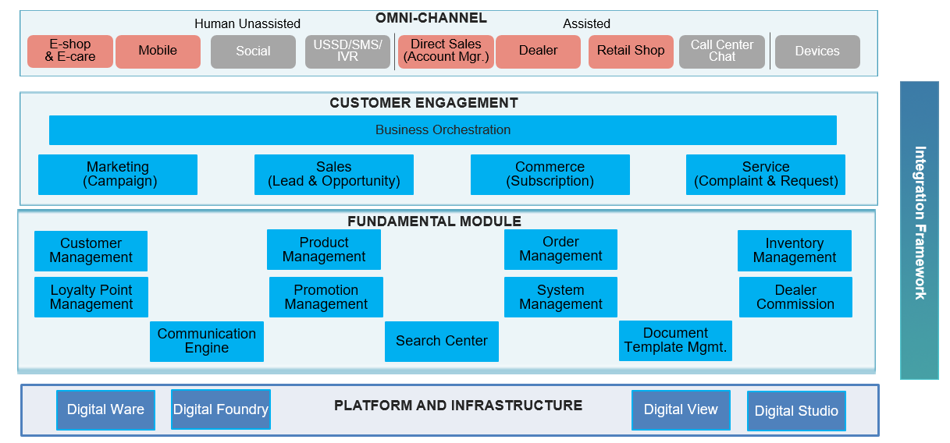

1. **Test Results**

