**TM Forum Open APIs**

**Conformance Certification**

*Company Name:* ***Huawei Technologies Co. Ltd***

*TM Forum Open API Name:* ***TMF632 Party Management API***

*TM Forum Open API Release Version:* ***R19.0 /v4.0.1***

**Report Date: 29-12-2020**

1. **What Product or Solution does your API support?**

Huawei BSS is meant to support customer-related business process for Telco, accelerate the business innovation, faster TTM via advanced micro-service architecture, service agility with a real-time, open end-to-end commerce and subscription capabilities solution.

Around the globe, the leading operators are on the way to digital customer engagement with Huawei solution together.

A key component of the solution is Party Management. The Party Management API provides an interaction interface with this module and relevant functionalities of Huawei BSS. The external systems and the third-parties can access such capabilities via this exposed API.

1. **Overview of Certified API**

Party is created to record an individual or an organization before the assignment of any role.

***Party API*** manages the following data resources:

***Individual***

Individual represents a single human being (a man, woman or child). The individual can be a customer, an employee or any other person that the organization needs to store information about.

***Organization***

Organization represents a group of people identified by shared interests or purpose. Examples include business, department and enterprise. Because of the complex nature of many businesses, both organizations and organization units are represented by the same data.

According to *Party Management Conformance Profile* (TMF632B), the following table indicates which ones are mandatory and which ones are optional for Customer resource

|  |  |  |
| --- | --- | --- |
| Operation | Mandatory/Optional | Comments |
| GET | M | GET must be used to retrieve a representation of a resource |
| POST | M | POST must be used to create a new resource |
| PUT | O for all resources | PUT must be used to update globally a resource |
| PATCH | O for all resources | PATCH must be used to partially update a resource. |
| DELETE | M | DELETE must be used to remove a resource |

1. **Architectural View**

The following diagram shows a functional architecture view of Huawei BSS:

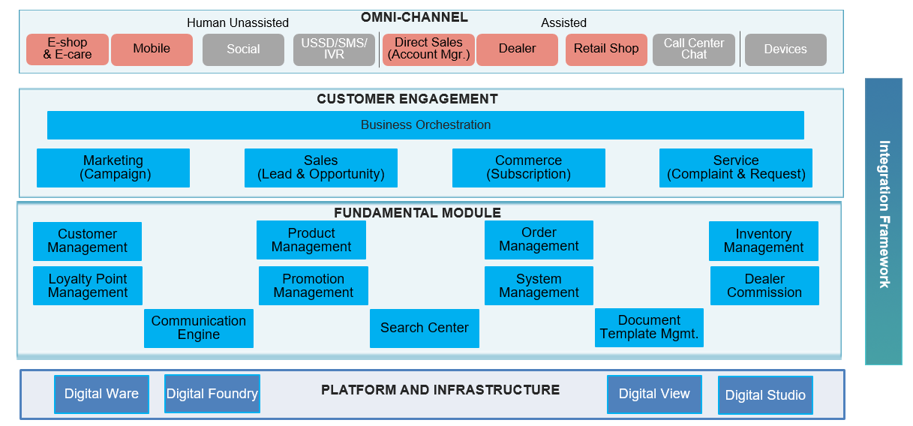

1. **Test Results**

