**TM Forum Open APIs**

**Conformance Certification**

*Company Name:* ***Huawei Technologies Co. Ltd***

*TM Forum Open API Name:* ***TMF637 Product Inventory API***

*TM Forum Open API Release Version:* ***R19.0 /v4.0.1***

**Report Date: 29-12-2020**

1. **What Product or Solution does your API support?**

Huawei BSS is meant to support customer-related business process for Telco, accelerate the business innovation, faster TTM via advanced micro-service architecture, service agility with a real-time, open end-to-end commerce and subscription capabilities solution.

Around the globe, the leading operators are on the way to digital customer engagement with Huawei solution together.

A key component of the solution is Product Management. The Product Inventory API of this module provides an interaction interface with this module and relevant functionalities of Huawei BSS. The external systems and the third-parties can access such capabilities via this exposed API.

1. **Overview of Certified API**

***Product Inventory API*** provides a standardized mechanism to retrieve product inventory information. The API consists of a simple set of operations that interact with Inventory systems in a consistent manner. Usually, a product is created and modified consequently to product order bit could be also ‘directly’ modified for administrative reason.

***Product Inventory API*** manages product resource:

A Product represents an instance of a product offering subscribed to by a party, such as a customer, the place where the product is in use, as well as configuration characteristics, such as assigned telephone numbers and internet addresses. The Product also tracks the services and/or resources through which the product is realized.

According to *Party Management Conformance Profile* (TMF637B), the following table indicates which ones are mandatory and which ones are optional for Customer resource

|  |  |  |
| --- | --- | --- |
| Operation | Mandatory/Optional | Comments |
| GET | M | GET must be used to retrieve a representation of a resource |
| POST | O  (used only for admin reason) | POST must be used to create a new resource |
| PATCH | O  (used only for admin reason) | PATCH must be used to partially update a resource. |
| DELETE | O  (used only for admin reason) | DELETE must be used to remove a resource |

1. **Architectural View**

The following diagram shows a functional architecture view of Huawei BSS:

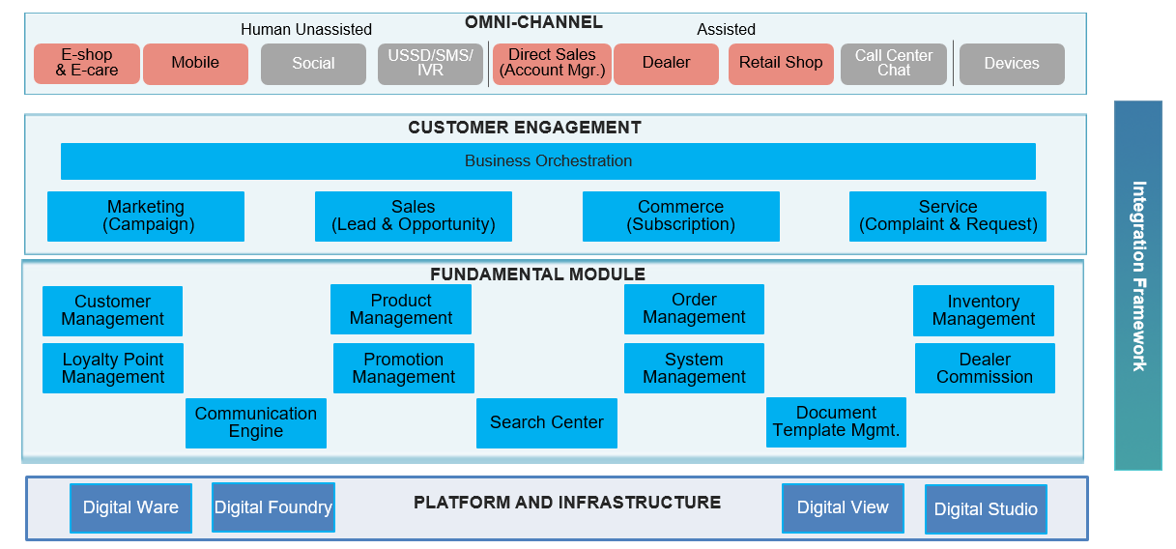

1. **Architectural View**

