**TM Forum Open APIs**

**Conformance Certification**

*Company Name:* ***Huawei Technologies Co. Ltd***

*TM Forum Open API Name:* ***TMF639 Resource Inventory Management API***

*TM Forum Open API Release Version:* ***R20.5 /v4.0.0***

**Report Date: 14-01-2021**

1. **What Product or Solution does your API support?**

Huawei BSS is meant to support customer-related business process for Telco, accelerate the business innovation, faster TTM via advanced micro-service architecture, service agility with a real-time, open end-to-end commerce and subscription capabilities solution.

Around the globe, the leading operators are on the way to digital customer engagement with Huawei solution together.

A key component of the solution is Inventory Management. The Resource Inventory Management API of this module provides an interaction interface with this module and relevant functionalities of Huawei BSS. The external systems and the third-parties can access such capabilities via this exposed API.

1. **Overview of Certified API**

The intent of Resource Inventory Management API is to provide a consistent/standardized mechanism to query and manipulate the resources of the inventory.

Resource is an abstract entity that describes the common set of attributes shared by all concrete resources (e.g. TPE, EQUIPMENT) in the inventory.

According to *Resource Inventory Management Conformance Profile* (TMF639B), the following table indicates which ones are mandatory and which ones are optional for Customer resource

|  |  |  |
| --- | --- | --- |
| Operation | Mandatory/Optional | Comments |
| GET | M | GET must be used to retrieve a representation of a resource |
| POST | M | POST must be used to create a new resource |

1. **Architectural View**

The following diagram shows a functional architecture view of Huawei BSS:

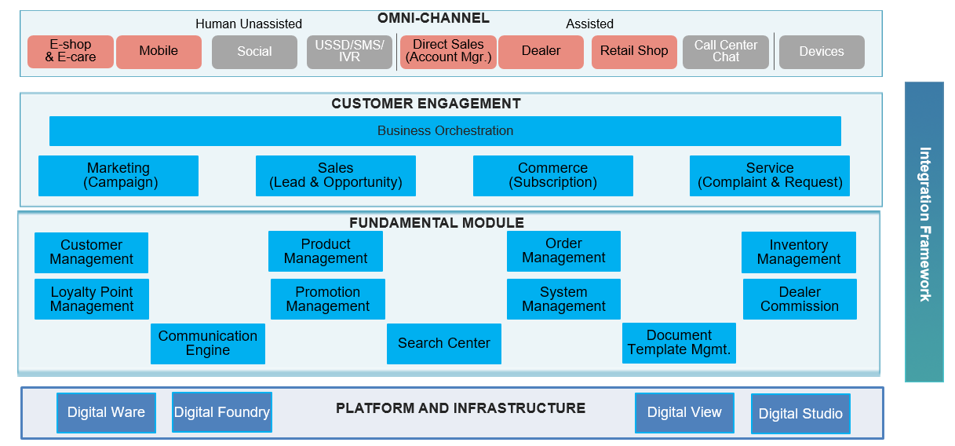

1. **Architectural View**

