**TM Forum Open APIs**

**Conformance Certification**

*Company Name:* ***Huawei Technologies Co. Ltd***

*TM Forum Open API Name:* ***TMF651 Agreement Management API***

*TM Forum Open API Release Version:* ***R19.0 /v4.0.0***

**Report Date: 31-12-2020**

1. **What Product or Solution does your API support?**

Huawei BSS is meant to support customer-related business process for Telco, accelerate the business innovation, faster TTM via advanced micro-service architecture, service agility with a real-time, open end-to-end commerce and subscription capabilities solution.

Around the globe, the leading operators are on the way to digital customer engagement with Huawei solution together.

A key component of the solution is Product Management. The Agreement Management API of this module provides an interaction interface with this module and relevant functionalities of Huawei BSS. The external systems and the third-parties can access such capabilities via this exposed API.

1. **Overview of Certified API**

The Agreement API provides standardized mechanism for managing agreements, especially in the context on partnerships between partners.

The API allows creation, update and query of agreement instances as well as creation, update and query of agreement specifications – serving as templates for agreement instances.

According to *Agreement Management Conformance Profile* (TMF651B), the following table indicates which ones are mandatory and which ones are optional for Customer resource

|  |  |  |
| --- | --- | --- |
| Operation | Mandatory/Optional | Comments |
| GET | M | GET must be used to retrieve a representation of a resource |
| POST | M | POST must be used to create a new resource |
| PUT | O for all resources | PUT must be used to update globally a resource |
| PATCH | O for all resources | PATCH must be used to partially update a resource. |
| DELETE | M | DELETE must be used to remove a resource |

1. **Architectural View**

The following diagram shows a functional architecture view of Huawei BSS:

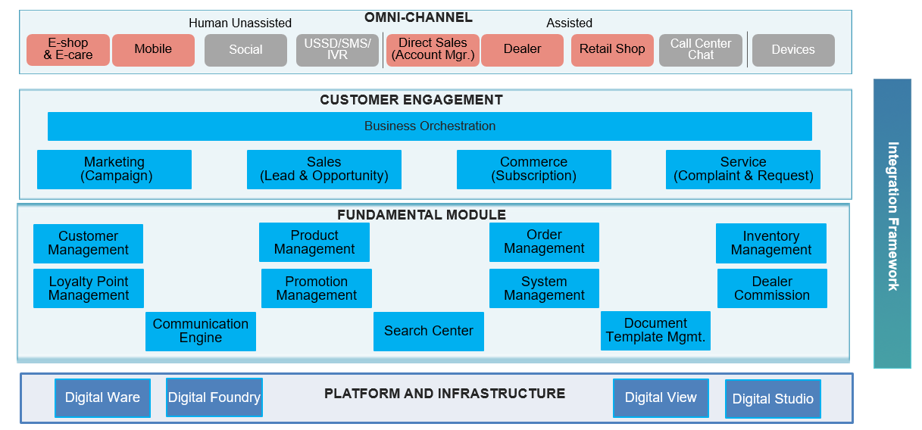

1. **Test Results**

