**TM Forum Open APIs**

**Conformance Certification**

*Company Name:* ***Huawei Technologies Co. Ltd***

*TM Forum Open API Name:* ***TMF 663 Shopping Cart API***

*TM Forum Open API Release Version:* ***R19.0.1 /v4.0.0***

**Report Date: 16th of December, 2020**

1. **What Product or Solution does your API support?**

Huawei BSS is meant to support customer-related business process for Telco, accelerate the business innovation, faster TTM via advanced micro-service architecture, service agility with a real-time, open end-to-end commerce and subscription capabilities solution.

Around the globe, the leading operators are on the way to digital customer engagement with Huawei solution together.

**Shopping Cart in Huawei BSS**

A key component of the solution is Shopping Cart module (part of “Commerce” inside Huawei BSS). The Shopping Cart API provides an interaction interface with this module and relevant functionalities of Huawei BSS. The external systems and the third-parties can access such capabilities via this exposed API.

1. **Overview of Certified API**

*Shopping Cart* API provides standardized mechanism for the management of shopping carts. Including creation, update, retrieval, deletion and notification of event. Shopping Cart entity is used for the temporarily selection and reservation of product offerings in e-commerce and retail purchase

*Shopping Cart resource* is used for the temporarily selection and reservation of product offerings in e-commerce, call center and retail purchase.

According to *Shopping Cart Conformance Profile* (TMF663B), the following table indicates which ones are mandatory and which ones are optional for Customer resource:

|  |  |  |
| --- | --- | --- |
| Operation | Mandatory/Optional | Comments |
| GET | M | GET must be used to retrieve a representation of a resource |
| POST | M | POST must be used to create a new resource |
| PATCH | O | PATCH must be used to partially update a resource. |
| DELETE | O | DELETE must be used to remove a resource |

1. **Architectural View**

The following diagram shows a functional architecture view of Huawei BSS:

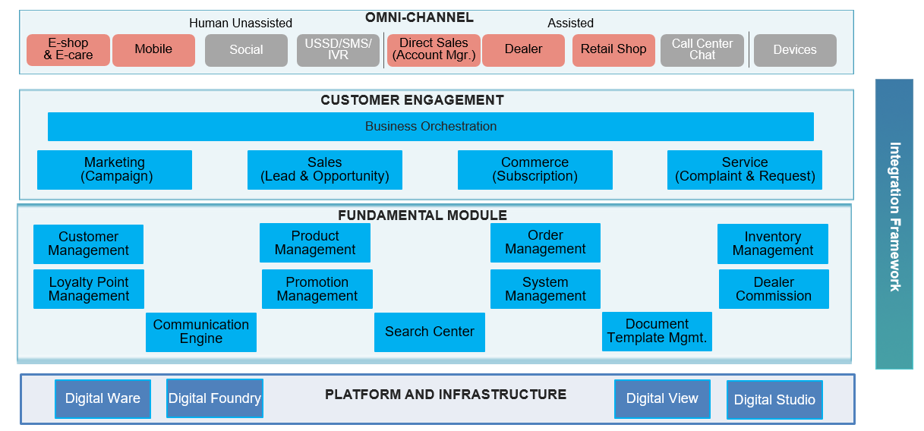

1. **Test Results**

