**TM Forum Open APIs**

**Conformance Certification**

*Company Name:* ***Huawei Technologies Co. Ltd***

*TM Forum Open API Name:* ***TMF666 Account Management API***

*TM Forum Open API Release Version:* ***R19.0 /v4.0.0***

**Report Date: 31-12-2020**

1. **What Product or Solution does your API support?**

Huawei BSS is meant to support customer-related business process for Telco, accelerate the business innovation, faster TTM via advanced micro-service architecture, service agility with a real-time, open end-to-end commerce and subscription capabilities solution.

Around the globe, the leading operators are on the way to digital customer engagement with Huawei solution together.

A key component of the solution is Customer Management. The Account Management API of this module provides an interaction interface with this module and relevant functionalities of Huawei BSS. The external systems and the third-parties can access such capabilities via this exposed API.

1. **Overview of Certified API**

The Account API provides standardized mechanism for the management of billing and settlement accounts, as well as for financial accounting (account receivable) either in B2B or B2B2C contexts.

It allows creation, update and retrieval of account information either in a B2B2C relationship context (creation of mass market customer billing account within a “Billing on Behalf of” process for example) or in a B2B context (creation of a billing/settlement account for a partner or B2B customer).

It also allows creation and query of bill items allowing partners or B2B customer to check their invoice.

According to *Account Management Conformance Profile* (TMF666B), the following table indicates which ones are mandatory and which ones are optional for Customer resource

|  |  |  |
| --- | --- | --- |
| Operation | Mandatory/Optional | Comments |
| GET | M | GET must be used to retrieve a representation of a resource |
| POST | M | POST must be used to create a new resource |
| PUT | O for all resources | PUT must be used to update globally a resource |
| PATCH | M | PATCH must be used to partially update a resource. |
| DELETE | M | DELETE must be used to remove a resource |

1. **Architectural View**

The following diagram shows a functional architecture view of Huawei BSS:

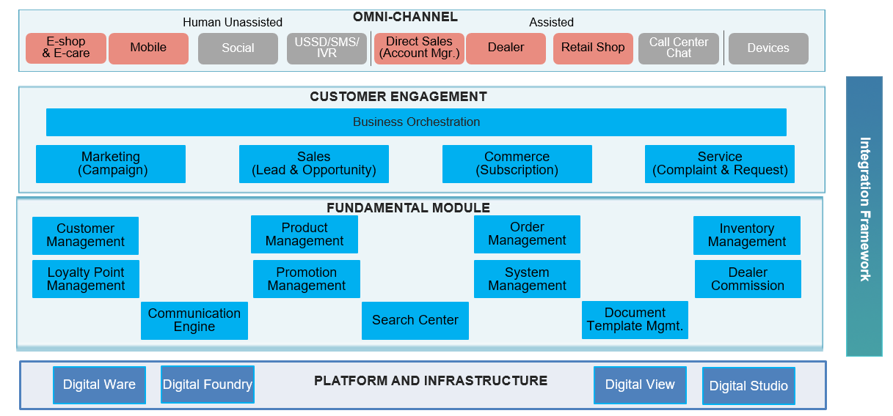

1. **Test Results**

