**TM Forum Open APIs**

**Conformance Certification**

*Company Name:* ***Huawei Technologies Co. Ltd***

*TM Forum Open API Name:* ***TMF669 Party role API***

*TM Forum Open API Release Version:* ***R19.0 /v4.0.0***

**Report Date: 29-12-2020**

1. **What Product or Solution does your API support?**

Huawei BSS is meant to support customer-related business process for Telco, accelerate the business innovation, faster TTM via advanced micro-service architecture, service agility with a real-time, open end-to-end commerce and subscription capabilities solution.

Around the globe, the leading operators are on the way to digital customer engagement with Huawei solution together.

A key component of the solution is Party Management. The Party Role API of this module provides an interaction interface with this module and relevant functionalities of Huawei BSS. The external systems and the third-parties can access such capabilities via this exposed API.

1. **Overview of Certified API**

Party Role API can be seen as a generalization of Customer management API where Party Roles may be any – not only a Customer. It shares in fact the same data structure than the Customer API but its use is intended in more general case, for instance within a partnership where the defined roles depend on the partnership kind.

According to *Party Role Management Conformance Profile* (TMF669B), the following table indicates which ones are mandatory and which ones are optional for Customer resource

|  |  |  |
| --- | --- | --- |
| Operation | Mandatory/Optional | Comments |
| GET | M | GET must be used to retrieve a representation of a resource |
| POST | M | POST must be used to create a new resource |
| PATCH | M (JSON-MERGE)  O (JSON-PATCH) | PATCH must be used to partially update a resource.  Support of Json merge is mandatory, support of json-path is optional. |
| DELETE | M | DELETE must be used to remove a resource |

1. **Architectural View**

The following diagram shows a functional architecture view of Huawei BSS:

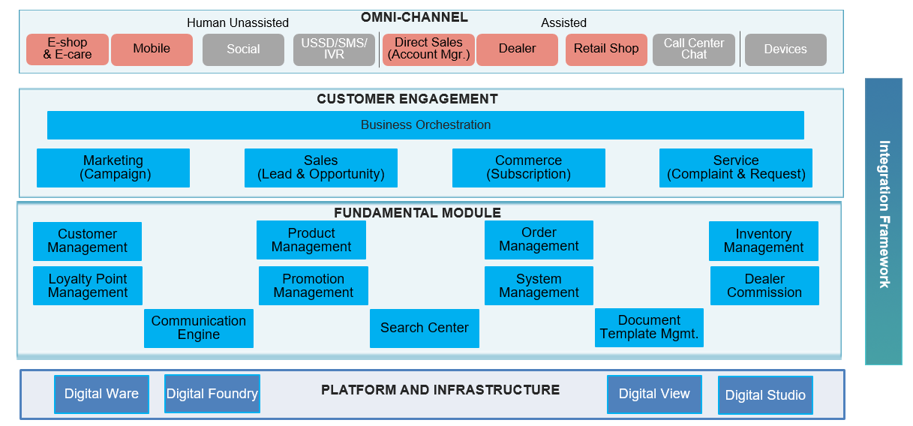

1. **Test Results**

