**TM Forum Open APIs**

**Conformance Certification**

*Company Name:* ***Ericsson***

*TM Forum Open API Name:*

***Service Catalog Management – TMF633***

*TM Forum Open API Release Version:* ***R20.5 / v4.0.0***

**Report Date: 14th April 2021**

1. **What Product or Solution does your API support?**

Ericsson Digital BSS handles complex operator´s requirements with a flexible, modular, cloud-based, 5G enabled, suite of products for all B2C, B2B and B2B2X revenue streams.

Coverage of this API includes:

* Ericsson Catalog Manager - a unique platform that cohesively supports the product lifecycle from offer creation to fulfillment. This catalog management system easily integrates with surrounding OSS/BSS solutions, providing key catalog features that include:
  + A centralized catalog. Use a single, consistent source of offerings, specifications, and underlying business rules to simplify product management and drive fulfillment, charging and assurance.
  + Graphical designer tool. Quickly create and assemble components into product specifications.
  + Scalable run-time access. Allow OSS/BSS and network systems to access catalog data in real time.

1. **Overview of Certified API**

The Service Catalog Management API is a true microservice part of Ericsson Catalog Manager.

1. **Architectural View**

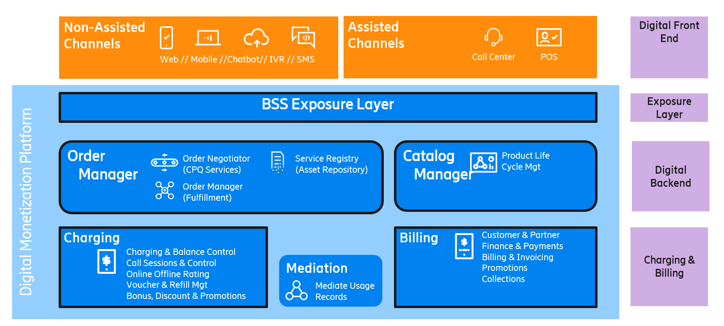

1. **Test Results**

