**TM Forum Open APIs**

**Conformance Certification**

*Company Name:* ***Globetom***

*TM Forum Open API Name:* ***TMF669 Party Role Management***

*TM Forum Open API Release Version:* ***19.0 – V4.0.0***

**Report Date: 6 May 2021**

# What Product or Solution does your API support?

All of Globetom’s TM Forum Open API implementations can be deployed in any one of the following models (on premise or in the cloud) - as a standalone API implementation on Globetom® ORCHA Digital Integration Hub or in addition, integrated with Globetom’s OSS/BSS platforms or with partner platforms or certified integrations with public cloud platforms.

## TMF669 Standalone Deployment (API + Globetom® ORCHA Digital Integration Hub)

The TMF669 API is deployed as a standalone API with an underpinning Hybrid Integration Platform based on our ORCHA iPaaS that implements the functions depicted in Figure 2 (see Architectural View). In this API deployment model, adopters of Globetom’s implementation are able to integrate their own OSS/BSS applications by using the Hub subscription mechanism and with Globetom’s implementation providing a very high degree of integrity of notifications to Hub subscribers to allow systems to leverage a loosely coupled integration pattern. The standalone deployment includes the following:

1. Deployment under any API gateway using a proxy deployment model.
2. A fully-fledged API backend for TMF669 to which the API calls are routed as part of the Proxy setup.
3. A Hybrid Integration Platform (HIP) that enables seamless decoupling and integration into the BSS/OSS and cloud services ecosystem of CSPs/DSPs.
4. An OLTP object store for all API resources managed using the API that may be used in the customer implementation as part of an overall Master Data Management (MDM) strategy.
5. A fully abstracted Data Integration Hub that certifies the integrity of notifications to subscribers to the API using the standard TM Forum Open API Hub subscription mechanism.

## TMF669 Integrated Deployment with Globetom® Revenue Weaver Platform

In the integrated deployment model, TMF669 is pre-integrated with Globetom’s Revenue Weaver BSS platform. Revenue Weaver manages real-time transactional processing in Digital Ecosystems and performs real-time rating, charging and revenue assurance functions. The platform relies on accurate profiles for organisations and individuals and their roles in B2B2X ecosystems and uses this profiling for personalised rating and charging function implementations and for authorization of service use based on PartyRole assignments.

In this deployment model, TMF 669 would be typically deployed together with TMF632 (Party Management). The PartyRole Resources from TMF669 and Individual and Organization Resources from TMF 632 are stored in the ORCHA Canonical data store as golden records and are also integrated with the Revenue Weaver Subscriber Management Function (SMF) to create entity profiles for Individuals and Organizations together with their roles using the Revenue Weaver SMF. The SMF store manages key resources derived from TMF632 and TMF669 resource models using the structure depicted in Figure 1. The functions delivered by Revenue Weaver are as follows:

1. Individuals and Organization managed using TMF632 are stored as Subscriber (Party) resources in the Revenue Weaver SMF
2. PartyRole resources are modelled as Subscriber (Party) subscriptions for the EngagedParty, or a PartyRole Subscriber (Party) resource is created in the absence of an EngagedParty specification. A PartyRole subscription resource is created and managed for the parent Party.
3. If accounts are specified, accounts for the PartyRole resources are created and are associated with the PartyRole.

A major advantage of Globetom’s TMF632 and TMF669 implementations is that they are natively multi-tenant to match the multi-tenancy of Revenue Weaver. The tenant owning a collection of Individual and Organization resources together with their roles is identified in production environments from the API security credentials and this enables the use of one TMF632 and TMF669 API deployment to manage multiple consumer’s TMF632 and TMF669 resources.

Figure 1 – Globetom Revenue Weaver components and the use of the TMF 632 and TMF669 standards

# Overview of Certified API

The Globetom pre-integrated TMF669 Party Management API is used to manage roles of parties that are engaged with CSPs/DSPs as Individuals and Organizations. After Individuals and Organizations are created using the TMF 632, consumers can assign multiple roles to these parties using the TMF 669 API to create context for the parties when they engage with the CSP/DSP.

The API implementation allows the following operations:

* Creation of Party Role resource using the POST operation
* Modifying of Party Role resource using the PATCH operation
* Retrieval of a single Party Role resource using the GET operation
* Retrieval of a list of Party Role resources using the GET operation and using filtering specifications conforming to the TMF630 REST API Design Guidelines Part 1
* Deleting of a Party Role resource using the DELETE operation
* Guaranteed notifications to subscribers to the API using the Hub subscription model with guaranteed sequence of notifications retained

# Architectural View

## Standalone deployment architectural view

The standalone deployment model architectural view is depicted in Figure 2. The standalone deployment can be used to deliver a Master Data Store for Party Role resources and this can be integrated with the Service Subscription Hub which is a standard feature of all Globetom TM Forum certified API implementations. The Globetom implementation can therefore be used as an integration hub. Subscribed platforms can update their records in response to subscription notifications. These updates can either be updated with copies of the Party Role data originating from TMF669 change operations (co-existence Master Data Management Model) or the href to PartyRole objects can be stored in a registry (Registry Master Data Management). Alternatively, the Globetom TMF669 implementation can be used as a central data store for Party Role definitions (Centralisation Master Data Management) as the Party Role records can be accessed on demand and at scale from the Globetom TMF669 implementation.

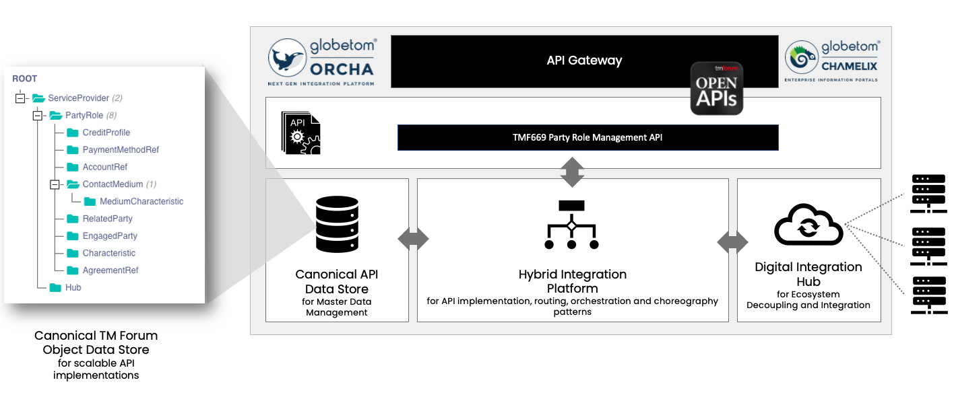

Figure 2 – Globetom’s TM Forum Open API Architecture Context

The standalone deployment may be used for Identity and Access Management solution integration, e.g. AWS IAM, Keycloak or similar in order to implement identity and access management functions. In this integration pattern, these platforms are integrated using the Event Subscription Hub for TMF669.

## Revenue Weaver integrated deployment architectural view

The architectural view for the deployment model in which Globetom’s Revenue Weaver platform is pre-integrated is depicted in Figure 3. This deployment is typically done in conjunction with TMF632 (Party Management). Parties are stored in response to TMF632 API operations in the Subscriber Management Function (SMF) of Revenue Weaver. Party Roles created and updated using TMF669 results in role subscriptions to be added to parties provisioned on Revenue Weaver. When Party Roles are created with Account references forming part of the Party Role, accounts are created and associated with the Party Role.

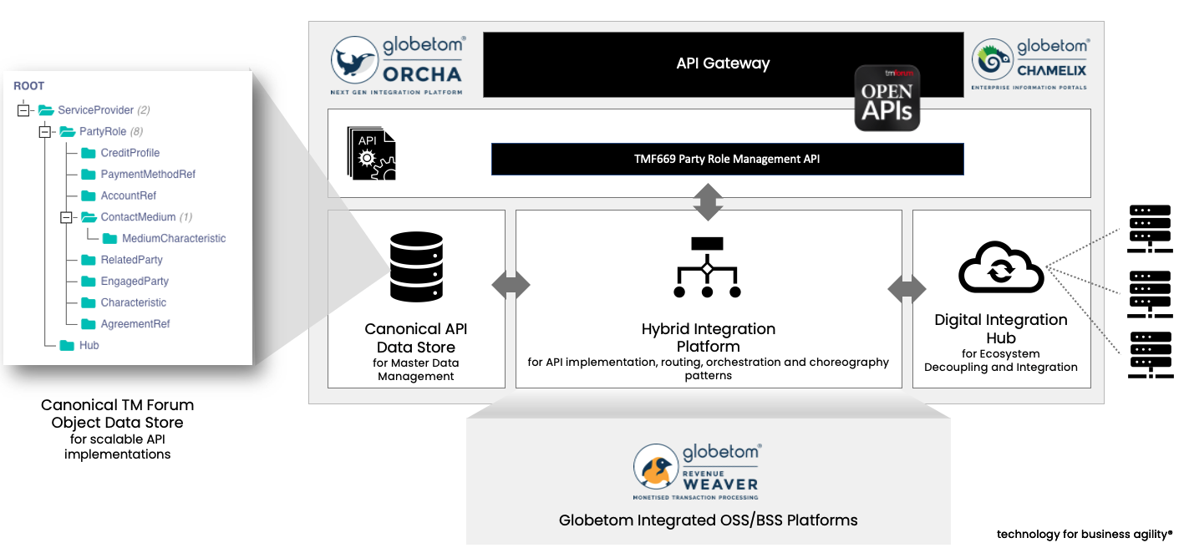

Figure 3 - TMF669 integrated with the Globetom Revenue Weaver BSS platform

## TMF669 use with TMF Open Digital Architecture (ODA)

The TMF669 API is presently proposed as a mandatory constituent of the Security function of an Open Digital Architecture (ODA) component. Deployment of TMF669 API support will therefore become a core part of the ODA component architecture.

# Test Results

