**TM Forum Open APIs**

**Conformance Certification**

*Company Name:* ***Ericsson***

*TM Forum Open API Name:*

***TMF663 - Shopping Cart Management***

*TM Forum Open API Release Version:* ***R19.0.1 / v4.0.0***

**Report Date: 26 May, 2021**

1. **What Product or Solution does your API support?**

Ericsson Digital BSS handles complex operator´s requirements with a flexible, modular, cloud-based, 5G enabled, suite of products for all B2C, B2B and B2B2X revenue streams. It includes:

* **Ericsson Charging:** A real-time, modular convergent charging solution for all business lines.
* **Ericsson Billing:** An end-to-end billing solution that combines out-of-the-box features and high configurability.
* **Ericsson Catalog Manager:** An enterprise and technical product catalog with superior user interface
* **Ericsson Order Care:** A dynamic, catalog-driven order orchestration and management with configurable workflows.
* **Ericsson Mediation:** A common data integration and processing layer for all industry, source and business model domains.

The **Ericsson Digital Monetization Platform** is Ericsson pre-integrated BSS stack for low-risk but effective digital transformation.

1. **Overview of Certified API**

The Shopping Cart Management API is a true microservice, and part of Ericsson Order Care.

1. **Architectural View**

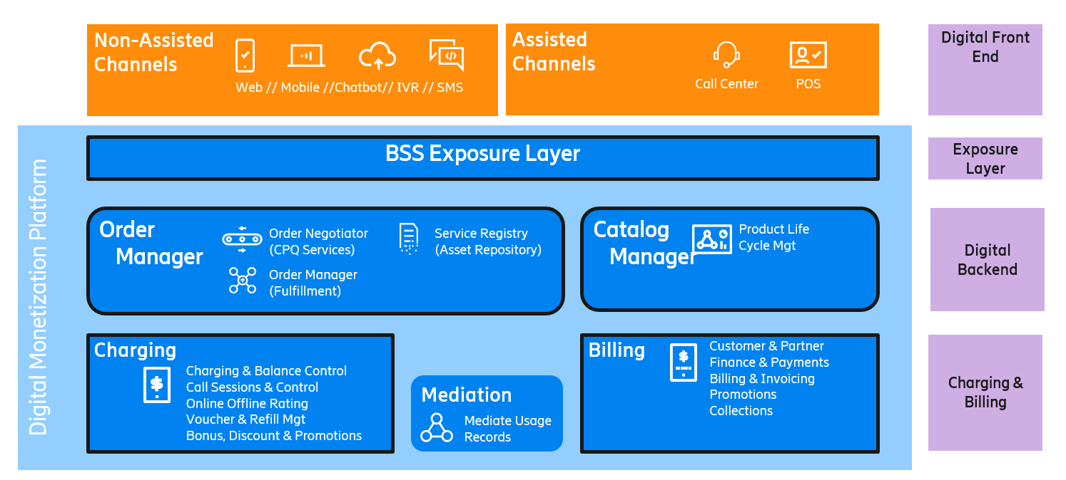

1. **Test Results**

