**TM Forum Open APIs**

**Conformance Certification**

*Company Name:* ***Huawei Technologies Co. Ltd***

*TM Forum Open API Name:*

***TMF 635 Usage Management API***

*TM Forum Open API Release Version:* ***R20.5/v4.0***

**Report Date: 28-05-2021**

1. **What Product or Solution does your API support?**

Huawei BSS provides digital service monetization engine for Telco, accelerate your business innovation, faster TTM via decoupled and layered architecture, service agility with a real-time, open end to end charging & billing capabilities solution. Leading operators are on the way to 5G commercialization.

**Usage Management in Huawei Convergent Billing for Mobile**

A key component of the solution is Dynamic Converged Rating and Charging Service. The Dynamic Converged Rating and Charging provides Usage management API. The Usage management API provides an interaction interface with the external systems and the third-parties. The external systems and the third-parties can manage usage via this exposed API.

1. **Overview of Certified API**

*Usage Management* provides a standardized mechanism for usage management such as the creation, update, and retrieval. And it includes two resources, one is Usage, another one is UsageSpecification.

*Usage Specification* API manages usage specification information

• A usage specification is a type of usage event that are of interest to the business and can have charges applied to it. It is comprised of characteristics, which define all attributes known for a particular type of usage.

• Main attributes of usage specification are:

1. id
2. isBundle
3. entitySpecRelationship : A list of entity specification relationships (EntitySpecificationRelationship [*]). Relationship to another specification
4. specCharacteristic: a list of characteristic specifications (CharacteristicSpecification [*]). List of characteristics that the entity can take.

*Usage Management* API manages usage management:

• Usage Event is an occurrence of employing a Product, Service, or Resource for its intended purpose, which is of interest to the business and can have charges applied to it. Here we have usage resource to describe this event.

• Main attributes of usage are:

1. id
2. usagespecification
3. RatedProductUsage: A list of rated product usages (RatedProductUsage [*]). An occurrence of employing a product for its intended purpose with all rating details
4. usageCharacteristic: A list of usage characteristics (UsageCharacteristic [*]). Provides the value of a given characteristic
5. usageType: a string, type of usage, such as: VOICE, SMS, DATA.
6. **Architectural View**

The following diagram shows a functional architecture view of Huawei BSS:

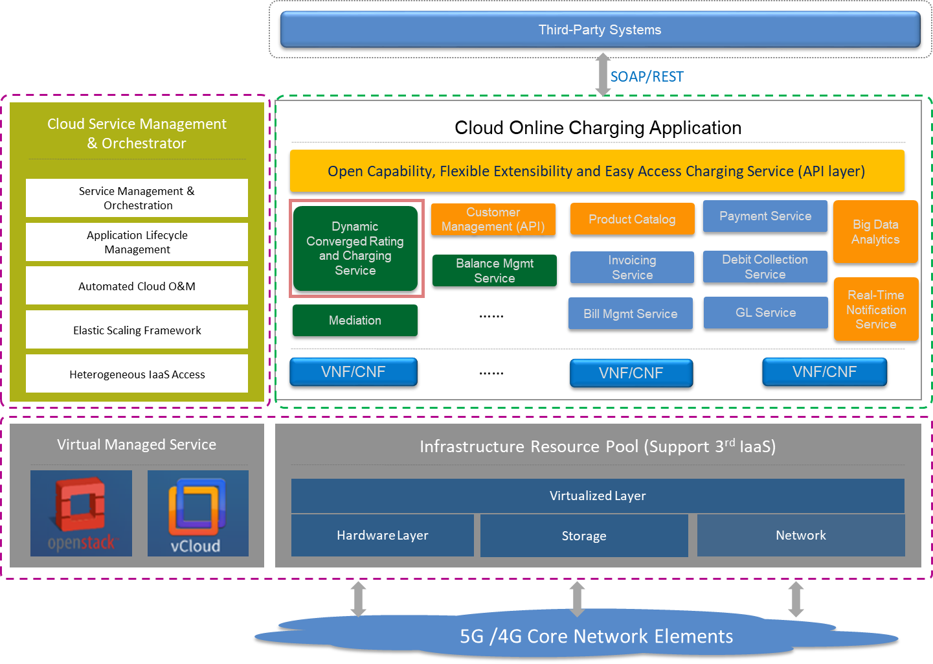

1. **Test Results**

