**TM Forum Open APIs**

**Conformance Certification**

*Company Name:* ***Huawei Technologies Co. Ltd***

*TM Forum Open API Name:*

***TMF 654 Prepay Balance Management API***

*TM Forum Open API Release Version:* ***R20.5 /v4.0***

**Report Date: 28-05-2021**

1. **What Product or Solution does your API support?**

Huawei BSS provides digital service monetization engine for Telco, accelerate your business innovation, faster TTM via decoupled and layered architecture, service agility with a real-time, open end to end charging & billing capabilities solution. Leading operators are on the way to 5G commercialization.

**Balance Management in Huawei Convergent Billing for Mobile**

A key component of the solution is Balance Management Service. The Balance Management API provides an interaction interface with the external systems and the third-parties. The external systems and the third-parties can access such capabilities via this exposed API. The balance management objects can be the main funds of prepaid or postpaid subscribers.

1. **Overview of Certified API**

*Prepay Balance Management* API is used to manage and track prepay users balance. And the most important concept is bucket which represent an entity that keeps track of the balance available to use service and it can be monetary or non-monetary. And the user balance includes a set to buckets.

And for the prepay users, they can have different transaction types, such as: top-up, adjustment, transfer in/out, reserve, each transaction has its own resources.

Here prepay balance APIs supply the ability to query prepay users’ balance and manage all transactions, the actions include: get, create, delete and so on.

1. **Architectural View**

The following diagram shows a functional architecture view of Huawei BSS:

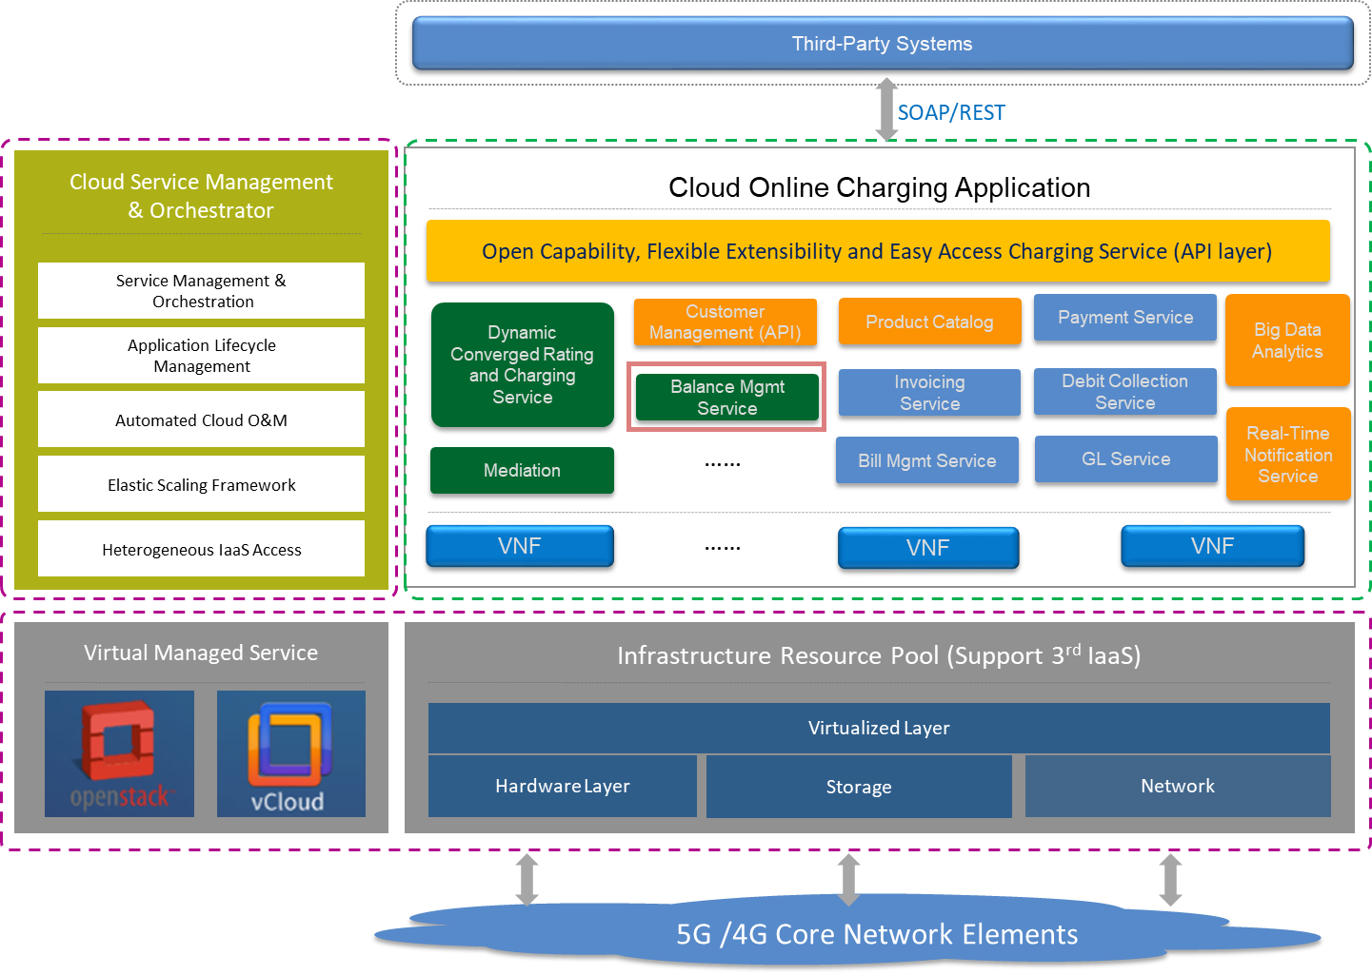

1. **Test Results**

