**TM Forum Open APIs**

**Conformance Certification**

*Company Name:* ***Huawei Technologies Co. Ltd***

*TM Forum Open API Name:*

***TMF 677 Usage Consumption API***

*TM Forum Open API Release Version:* ***R18.5.0 /v4***

**Report Date: 28-05-2021**

1. **What Product or Solution does your API support?**

Huawei BSS provides digital service monetization engine for Telco, accelerate your business innovation, faster TTM via decoupled and layered architecture, service agility with a real-time, open end to end charging & billing capabilities solution. Leading operators are on the way to 5G commercialization.

**Usage Consumption in Huawei Convergent Billing for Mobile**

A key component of the solution is Dynamic Converged Rating and Charging Service. The Dynamic Converged Rating and Charging provides Usage Consumption API. The Usage Consumption API provides an interaction interface with the external systems and the third-parties. The external systems and the third-parties can access usage consumption info via this exposed API.

1. **Overview of Certified API**

*Usage consumption* API provides the ability to manage consumption report. The consumption report providing ongoing information about usages related to any subscribed network products (voice, data, TV,…) without having to wait the invoice production, it shows the usage done and remaining credits on the bucket which comes from users purchased offers and options.

And we have the consumption report resource. Main attributes of consumption reports are:

1. id
2. bucket: a list of usage volume products. Buckets included in the offer or option subscribed.
3. entitySpecRelationship : A list of entity specification relationships (EntitySpecificationRelationship [*]). Relationship to another specification
4. relatedParty : A related party (RelatedParty). RelatedParty reference

Here the usage consumption APIs supply the ability to manage consumption resource, include create, get, delete operations and etc.

1. **Architectural View**

The following diagram shows a functional architecture view of Huawei BSS:

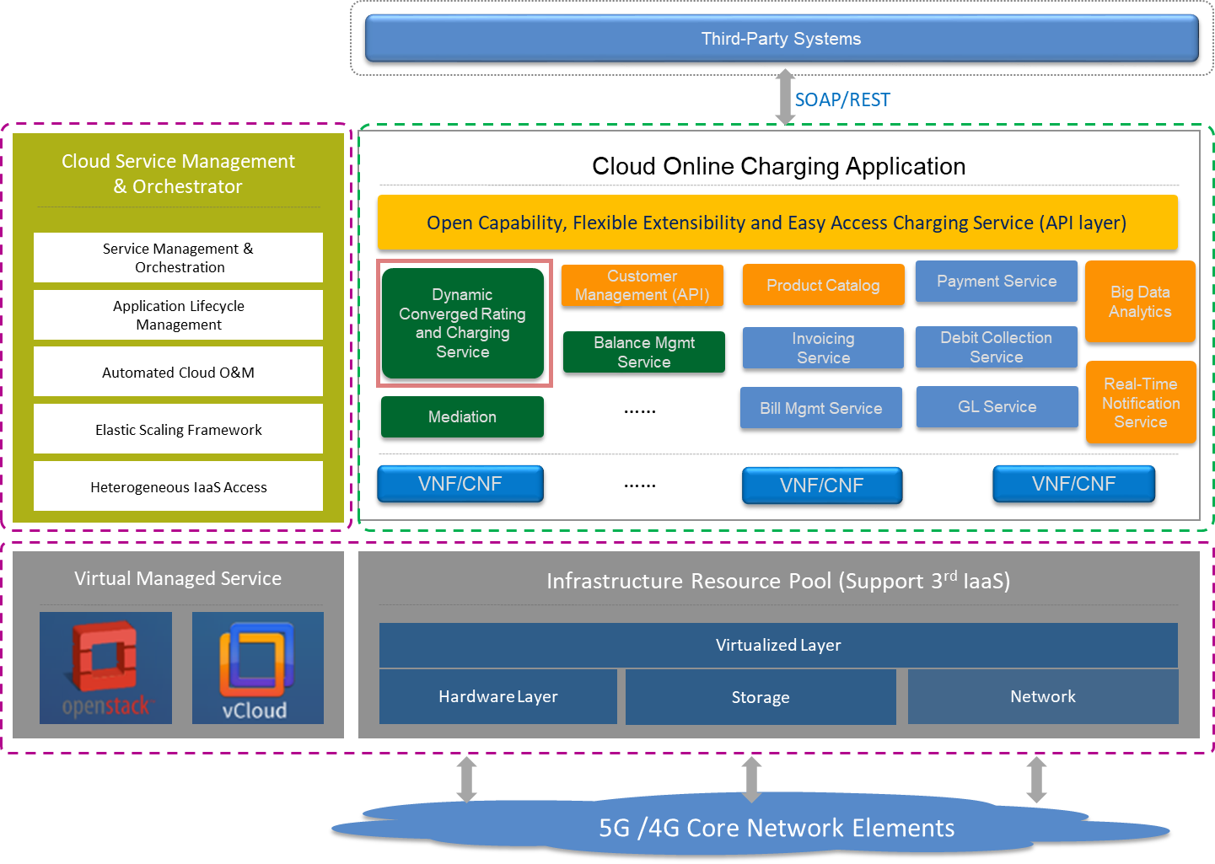

1. **Test Results**

