**TM Forum Open APIs**

**Conformance Certification**

*Company Name:* ***Tecnotree***

*TM Forum Open API Name:* ***Party Interaction Management API***

*TM Forum Open API Release Version:* ***R 20.5.0/v4.0.0***

**Report Date: 13th July 2021**

1. **What Product or Solution does your API support?**

In today’s dynamic market, connectivity is taken for granted and OTT players dream up new disruptions almost every day. Communication Service Providers (CSPs) face the unique challenge of retaining existing customers and remaining relevant, and, of course attracting new customers. This forces CSPs to adopt innovative strategies to simultaneously renew existing systems, processes and tools while adding new, complementary ones to stay future-proof, moving to becoming Digital Services Provider (DSP).

Digital Customer Lifecycle Manager (DCLM) 5.0.3 enables personalization of every customer’s experience by providing a consistent message across all channels and creation of a single view of each customer with information from all customer touchpoints.

**Omni-channel support**: A customer will be able choose when and where to interact with the DSP and be able to smoothly switch channels at any time and continue the interaction. Customer data will be consistent and seamlessly available across channels. DCLM will be the single source of truth for customer data.

**Analytics and KPIs**: DCLM provides DSPs the insights on customer behavior as well as on the performance of their CSRs and stores, using state-of-the-art analytics engine built into the system.

**Customer Centric Architecture**: DCLM enables DSPs to capture and maintain all customer related information. This eliminates duplication and customer data ambiguity, across various customer functional units. DCLM enables a unified convergent view of a customer and the related information across service lines and channels. It provides a 360-degree view of the customer including the history of interactions and service requests. DCLM users have access to customer information set that is aggregated, maintained, and managed across the enterprise.

1. **Overview of Certified API**

Party Interaction (Party can be a person/individual or an organization that has any kind of relationship with DSP/enterprise) is managed by the Tecnotree’s Digital Customer Lifecycle Manager (DCLM). DCLM provides Open APIs/REST based APIs in line with TM Forum defined specification for Party Interaction such as creation, update and retrieval (individuals or organizations), including filtering for all interactions.

Some of the Actual Operations supported over this API are

* + Retrieval of history of interaction of an individual or an organization
  + Type of Interaction
  + Interaction filter criteria such as based on status
  + Details of Interaction
  + Updating the status of interaction

The interaction history is displayed on the customer 360 Degree view in DCLM compiling all interactions with a particular customer and displays them in a comprehensive time-line. This includes any interaction that could be related to for example: a service purchase, a service request, trouble ticket, or financial.

1. **Architectural View**

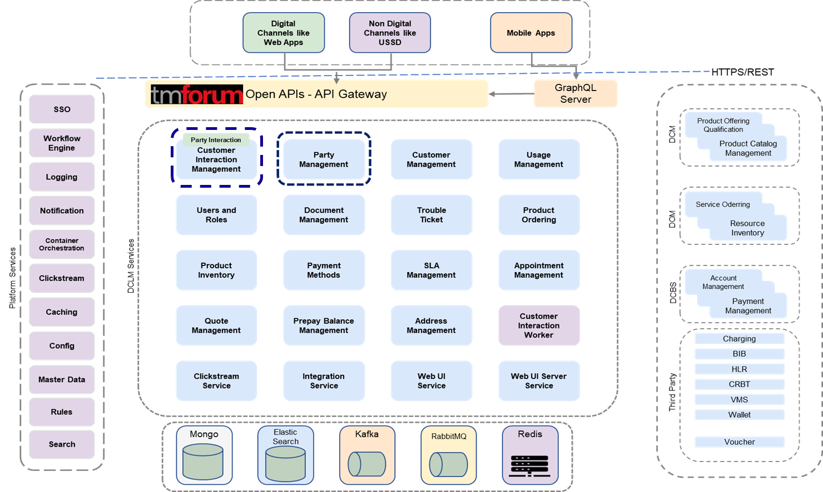

1. **Test Results**

