**TM Forum Open APIs**

**Conformance Certification**

*Company Name:* ***Tecnotree***

*TM Forum Open API Name:*

***TMF638 - Service Inventory Management API***

*TM Forum Open API Release Version:* ***20.5 / 4.0***

**Report Date: 21st September 2021**

1. **What Product or Solution does your API support?**

Tecnotree Digital Order Manager (DOM) is a catalog driven order manager that provides automation of various product and services enabling communication service providers (CSPs) to expand their current market from traditional GSM to a digital world. With the help of DOM, CSP can create various products and offerings as part of catalogue. DOM provides automation of delivery and fulfilment of product, services and resources.

DOM provides a unified platform for order fulfilment and processing with built-in integration of various Tecnotree digital products such as Digital Catalog Manager (DCM) for product, service and resource construct, Digital Customer Lifecycle Manager (DCLM) for capturing customer order and request, Digital Convergent Billing System (DCBS) for managing subscriber billing and invoicing. Additionally, DOM has the capability to integrate with other upstream or downstream that is compliant with TM Forum standards.

DOM offers following key benefits to CSPs:

* Unify order processing and fulfilment
* Centralize order tracking and monitoring
* Utilizing dynamic reusable microflows
* Catalog driven order processing
* Event driver order processing and fulfilment enabling processing future dated order
* Manual user task creation and activation
* TM Forum open API compliance

1. **Overview of Certified API**

DOM provides an API for querying and manipulating the service inventory. When a product is processed by DOM, as part of product order, DOM decomposes the order items into services and resources. As part of this service order processing and fulfilment, DOM maintains an inventory for the processed service.

This service can be queried by channels such as Self-Care or CRM to get the current status of the customer service.

1. **Architectural View**

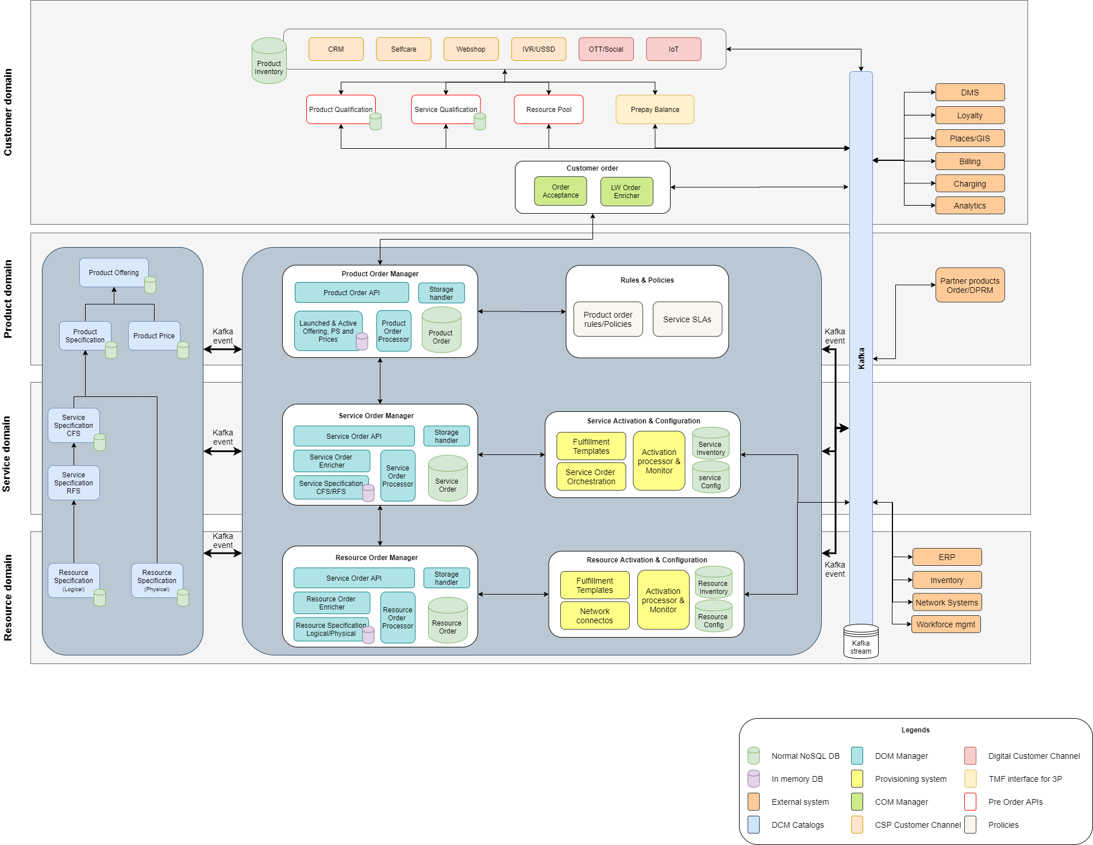

1. **Test Results**

