**TM Forum Open APIs**

**Conformance Certification**

*Company Name:* ***Tecnotree***

*TM Forum Open API Name:*

***TMF641 - Service Ordering Management API***

*TM Forum Open API Release Version:* ***R 21.0 / 4.1***

**Report Date: 27th September 2021**

1. **What Product or Solution does your API support?**

Tecnotree Digital Order Manager (DOM) is a catalog driven order manager that provides automation of various product and services enabling communication service providers (CSPs) to expand their current market from traditional GSM to a digital world. With the help of DOM, CSP can create various products and offerings as part of catalogue. DOM provides automation of delivery and fulfilment of product, services and resources.

DOM provides a unified platform for order fulfilment and processing with built-in integration of various Tecnotree digital products such as Digital Catalog Manager (DCM) for product, service and resource construct, Digital Customer Lifecycle Manager (DCLM) for capturing customer order and request, Digital Convergent Billing System (DCBS) for managing subscriber billing and invoicing. Additionally, DOM has the capability to integrate with other upstream or downstream that is compliant with TM Forum standards.

DOM offers following key benefits to CSPs:

* Unify order processing and fulfilment
* Centralize order tracking and monitoring
* Utilizing dynamic reusable microflows
* Catalog driven order processing
* Event driver order processing and fulfilment enabling processing future dated order
* Manual user task creation and activation
* TM Forum open API compliance

1. **Overview of Certified API**

Service Order, which is the implementation of TMF641 provides the product order manager to trigger action (for example add, modify, or terminate) on the service (customer-facing service and/or resource-facing service).

After order decomposition, DOM internally triggers service order to process the service order. The Service Order Management component manages the end-to-end lifecycle of a service request. This includes service order issuance, and service order tracking along with the orchestration of activation.

1. **Architectural View**

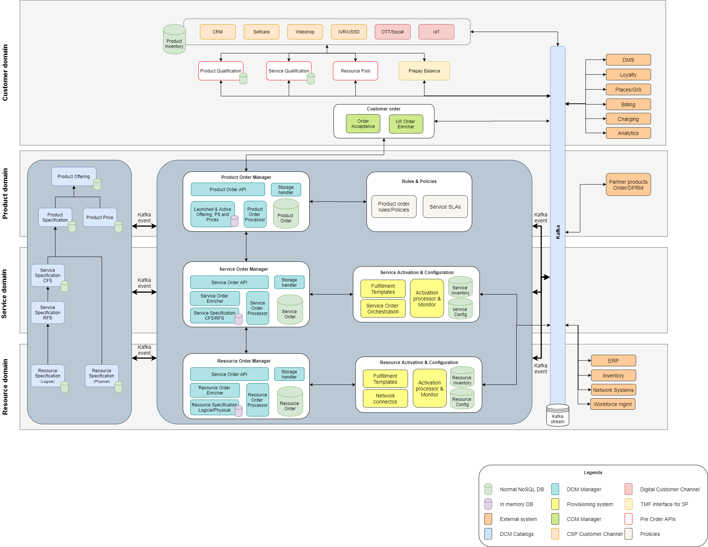

1. **Test Results**

