**TM Forum Open APIs**

**Conformance Certification**

*Company Name:* ***Tecnotree***

*TM Forum Open API Name:*

***TMF651 - Agreement Management API***

*TM Forum Open API Release Version:* ***19.0 / 4.0***

**Report Date: 21st September 2021**

1. **What Product or Solution does your API support?**

Market opportunities and evolving customer needs have encouraged Communication Service Providers (CSP) in broadening their operations and managing multiple lines of businesses (LOBs). Such expansions have compounded the complexity of their products and services and resulted into multiple OSS and BSS systems in their operational landscapes. At the same time, there is an intense pressure of enhancing customer experience and declining traditional revenue streams.

Tecnotree Digital Catalog Manager (DCM) is a central repository of products that spans across multiple lines of businesses. DCM plays a vital role in CSP’s environment by providing the integration of products and resources across the business and operational support systems (B/OSS), thus contributing to both the current and emerging market opportunities by helping them surge ahead of the competition.

Tecnotree Digital Catalog Manager (DCM) helps unify product management and streamlines the process of product creation and launch. It provides CSPs the flexibility of phasing out legacy systems and migrating to strategic systems to meet their product management challenges. This comprehensive and detailed approach adopted by DCM is one of the core reasons for it becoming the tool that bolsters the CSPs’ business and operational strategy.

1. **Overview of Certified API**

In DCM a contract is an “agreement” between the Service Provider and the Service Consumer involving products, Services and/or resources.

Contracts are bound by terms and conditions. In addition, individual items that make up a contract may be bound by their own set of terms and conditions. Terms and conditions can include such things as exclusions, legal issues, and contract termination clauses.

Contracts can involve a number of Products, Services, and/or Resources, as well as their specifications. For example, an order from a new customer may specify a number of desired Product Offerings; a SLA (Service Level Agreement) may specify the Services covered by the Agreement.

Items on an Agreement may also be characterized by one or many prices. The price may be a one-off price or a price associated to a Product Offering (in the case of an order for a Product).

1. **Architectural View**

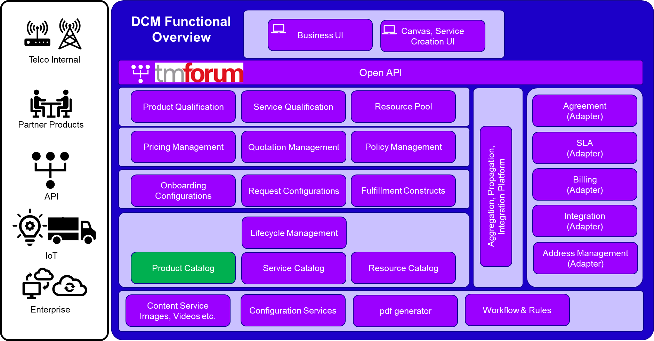

1. **Test Results**

