**TM Forum Open APIs**

**Conformance Certification**

*Company Name:* ***Tecnotree***

*TM Forum Open API Name:*

***TMF652 - Resource Ordering Management API***

*TM Forum Open API Release Version:* ***20.5 / 4.0***

**Report Date: 21st September 2021**

1. **What Product or Solution does your API support?**

Tecnotree Digital Order Manager (DOM) is a catalog driven order manager that provides automation of various product and services enabling communication service providers (CSPs) to expand their current market from traditional GSM to a digital world. With the help of DOM, CSP can create various products and offerings as part of catalogue. DOM provides automation of delivery and fulfilment of product, services and resources.

DOM provides a unified platform for order fulfilment and processing with built-in integration of various Tecnotree digital products such as Digital Catalog Manager (DCM) for product, service and resource construct, Digital Customer Lifecycle Manager (DCLM) for capturing customer order and request, Digital Convergent Billing System (DCBS) for managing subscriber billing and invoicing. Additionally, DOM has the capability to integrate with other upstream or downstream that is compliant with TM Forum standards.

DOM offers following key benefits to CSPs:

* Unify order processing and fulfilment
* Centralize order tracking and monitoring
* Utilizing dynamic reusable microflows
* Catalog driven order processing
* Event driver order processing and fulfilment enabling processing future dated order
* Manual user task creation and activation
* TM Forum open API compliance

1. **Overview of Certified API**

Resource Order, which is implementation of TMF652, provides the capability to trigger action (on physical and logical) resources of the enterprise infrastructure or inventory.

The Resource Order Manager component manages the end-to-end lifecycle of a resource order request. This includes resource order issuance, and resource order tracking along with the orchestration of activation.

1. **Architectural View**

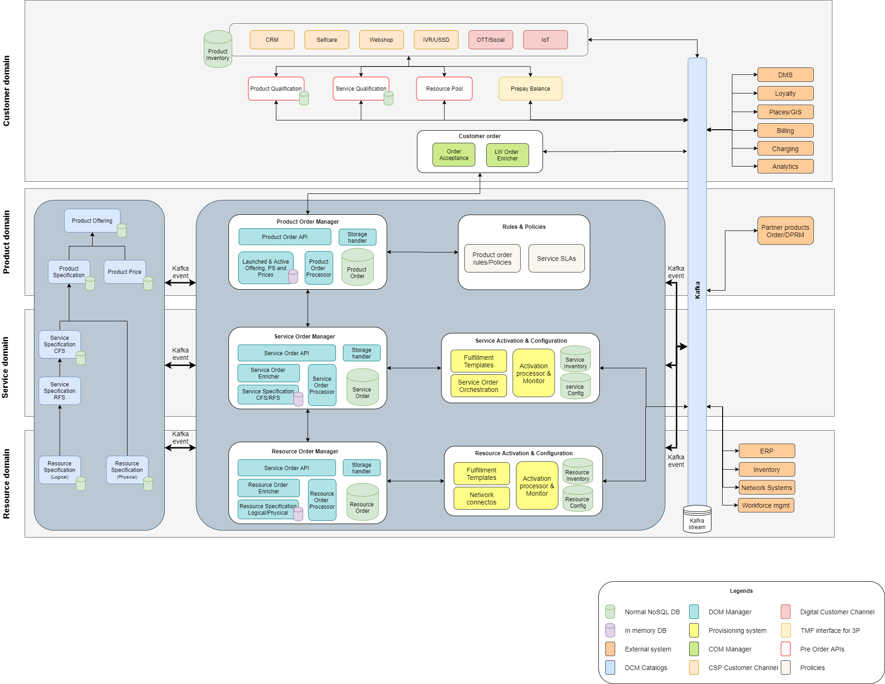

1. **Test Results**

