**TM Forum Open APIs**

**Conformance Certification**

*Company Name:* ***Tecnotree***

*TM Forum Open API Name:*

***TMF681 - Communication API***

*TM Forum Open API Release Version:* ***20.5 / 4.0***

**Report Date: 21st September 2021**

1. **What Product or Solution does your API support?**

Tecnotree Digital Accelerator platform powered by Microservices based architecture and acts as a comprehensive fulfilment tool that enables DSP to address the growing consumer appetite for services across the spectrum.

Below listed are the modules of Digital Accelerator Platform:

* **Digital API Manager** (API Gateway and Digital Integration Accelerator): Digital API Manager is bifurcated into two components i.e. API Gateway and Digital Integration Accelerator to act as a Single-Entry point supporting REST and Non REST based API communications.
* **Orchestrator**: Orchestrator provides a workflow engine for Microservices orchestration. Orchestrator ensures that once started, flows are always carried out fully, retrying steps in case of failures. Along the way, Orchestrator maintains a complete audit log so that the progress of flows can be monitored. Orchestrator is fault tolerant and scales seamlessly to handle growing transaction volumes.
* **Platform Services**: Operations Platform provides a common runtime environment for all Tecnotree applications. It is the operation, administration and maintenance (OA&M) subsystem.

1. **Overview of Certified API**

Notification services in DAP is implemented as a common shared service for all the IT applications. Whenever there is an application which needs to manage or send the message to the customer, this application can invoke the “communication” API to dispatch the notification.

Reach or Engage millions of customers over their preferred channels with just one API call.

Notification allows administrator to quickly define –

* When to send the notification
* Who receives the notification
* What content is in the notification

Notification is a pre-built common platform service. The user can easily engage with the customers over the preferred channel. The user can send notifications for low balance, threshold, birthday/ anniversary greetings, auto expiry/renewal/redemption, promotions and so on. Notification templates are also provided so that makes it simple to configure notifications. Notifications can be to an individual or group.

1. **Architectural View**

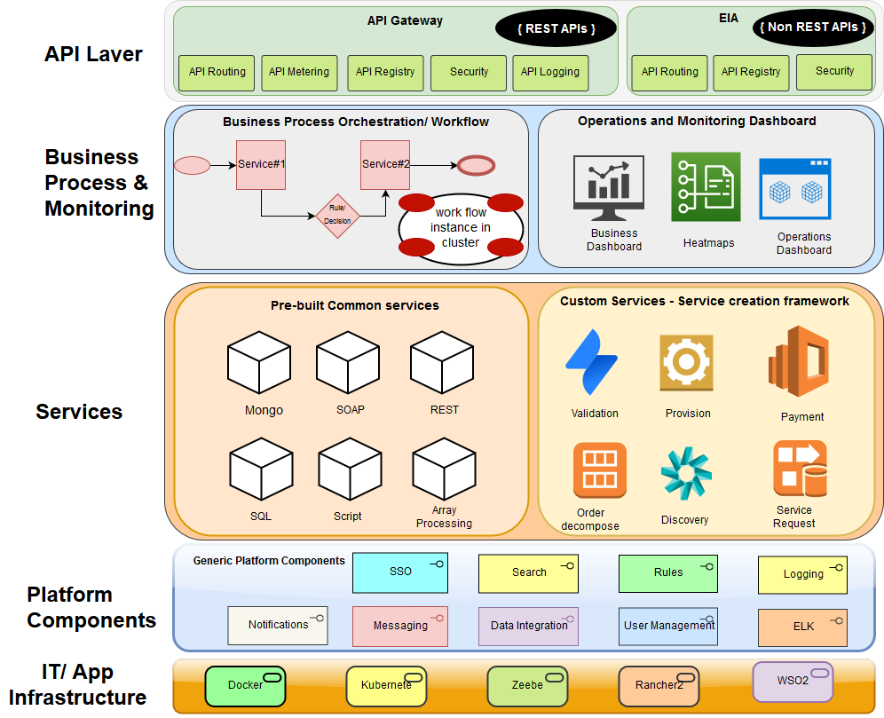

1. **Test Results**

