**TM Forum Open APIs**

**Conformance Certification**

*Company Name:* ***Tecnotree***

*TM Forum Open API Name:*

***TMF706 - test Data API***

*TM Forum Open API Release Version:* ***21.0 / 4.0***

**Report Date: 21st September 2021**

1. **What Product or Solution does your API support?**

Tecnotree Digital Accelerator platform powered by Microservices based architecture and acts as a comprehensive fulfilment tool that enables DSP to address the growing consumer appetite for services across the spectrum. Below listed are the modules of Digital Accelerator Platform:

* **Digital API Manager** (API Gateway and Digital Integration Accelerator): Digital API Manager is bifurcated into two components i.e. API Gateway and Digital Integration Accelerator to act as a Single-Entry point supporting REST and Non REST based API communications.
* **Orchestrator**: Orchestrator provides a workflow engine for Microservices orchestration. Orchestrator ensures that once started, flows are always carried out fully, retrying steps in case of failures. Along the way, Orchestrator maintains a complete audit log so that the progress of flows can be monitored. Orchestrator is fault tolerant and scales seamlessly to handle growing transaction volumes.
* **Platform Services**: Operations Platform provides a common runtime environment for all Tecnotree applications. It is the operation, administration and maintenance (OA&M) subsystem.

1. **Overview of Certified API**

Tecnotree Digital Accelerator platform’s Operations Platform provides a common runtime environment for all Tecnotree applications. It is the operation, administration and maintenance (OA&M) subsystem.

This API provides a standardized mechanism for the management of test data artifacts used for test case parameterization. These include Test Data Schemas and Test Data Instances.

1. **Architectural View**

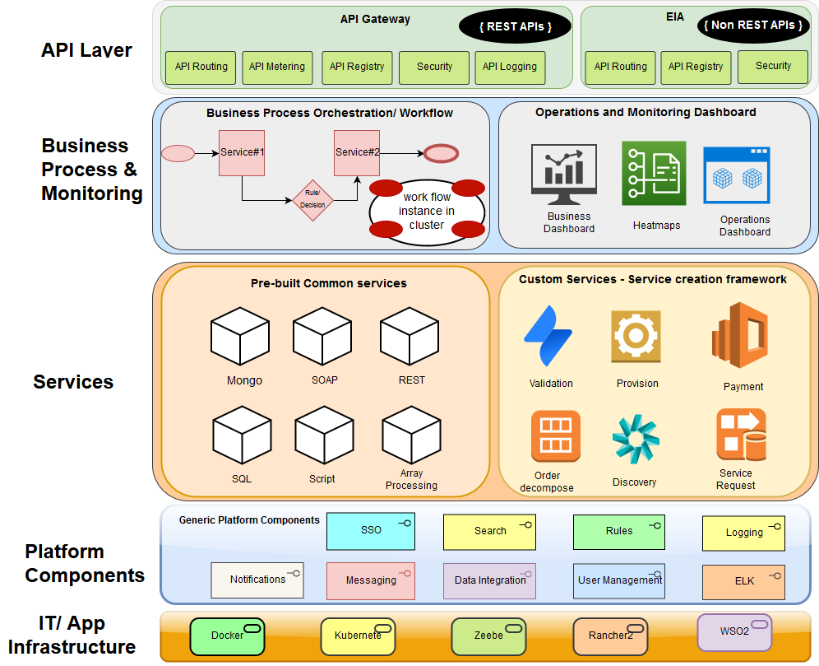

1. **Test Results**

