**TM Forum Open APIs**

**Conformance Certification**

*Company Name:* ***Tecnotree***

*TM Forum Open API Name:*

***Prepay Balance Management API – TMF 654***

*TM Forum Open API Release Version:* ***20.5 / 4.0***

**Report Date: 4th September 2021**

1. **What Product or Solution does your API support?**

We are in an era of Digital Transformation. The changes in technologies have been rapid and significant. Due to the revolution brought by invention of mobile phone and internet, people are increasingly connected with each other and to the online world.

This transformation necessitates the CSPs to re-invent themselves to provide a high performance, highly reliable infrastructure, which can scale based on requirement, but reduce the overall expenditure. A few years back, this was not possible when horizontal scaling (clone hardware for growth) was the only option available to the Operators. More Subscribers or more usage meant, buy more hardware. Hardware is expensive and does not guarantee seamless scaling with growth.

Tecnotree has decades of expertise in charging products and platform. By leveraging the same and investing in emerging digital technologies, Tecnotree is capable of catering to the vision and upscaling Charging as part of digital journey.

Tecnotree **DOCS (Digital Online Charging System)** provides a Standard based, highly flexible and feature rich rating and balance management solution allowing CSPs to capture revenue from any service, independently of the payment method and the delivery channel chosen by the subscriber.

Tecnotree DOCS supports Prepaid as well as Post-paid Subscriber base, with varied rating and charging services for Voice calls, SMS events and data sessions.

The flexible tariff configuration capabilities combined with an optional Policy Management functionality allows CSPs to gain back the control of the network usage and to offer intelligent data allowance bundles quickly, while allowing the addition of a variety of ARPU increasing “booster” packages.

Tecnotree DOCS introduces the unique user-payer paradigm allowing the user of the service to be separated from the payer. The user-payer relationship is configurable and can be set e.g. to allow all calls from children to their parents independently of the balance available on the child’s account. Combined with support for multi-level hierarchies and self-care functionality, the solution empowers the head of the family to decide what, when and how much of the sub-account owners’ (e.g. children) usage is paid for by the main account owner, allowing full control of communications expenditure of the whole family.

The same functionality can also be applied in a corporate context, to limit the company’s exposure to runaway usage of services by employees. In the enterprise context, the payer definition can be based on call type (e.g. local, national, international), event type (e.g. SM MO, SM MT, MMS MO) and date or time (e.g. national holiday, weekday/weekend, business hours/outside of business hours) among other criteria.

The solution supports multiple levels of account hierarchies with a top-down definition of credit limits. The hierarchy allows the account administrator (corporate manager or the head of the family) to manage the credit limit definition per service and per sub-hierarchy.

Combined with Tecnotree Enterprise VPN solution, the user-payer paradigm offers a flexible, yet easy to use way to gain full control of corporate or family communications spending while maintaining the benefits of a single-SIM solution for the users.

1. **Overview of Certified API**

Tecnotree OCS provides a Standard based, highly flexible and feature rich rating and balance management solution allowing DSPs to capture revenue from any service, independently of the payment method and the delivery channel chosen by the subscriber.

Tecnotree OCS supports Prepaid as well as Post-paid Subscriber base, with varied rating and charging services.

Prepay Balance Management API is managed by the Tecnotree’ s Digital Online Charging System (DOCS). DOCS provide Open APIs/REST Based APIs in line with TM Forum defined specification that allows management of the entire lifecycle of the Service catalog elements.

Prepay Balance Management API manages the balance, recharge (top-up) and transfer resources. The supported operations are:

1. Balance
2. Balance Deduct
3. Balance Top Up
4. Balance Transfer
5. Balance Adjustment
6. Bucket Balance
7. Accumulated Balance
8. Balance Activity
9. Balance Reserved
10. Balance Unreserved
11. **Architectural View**

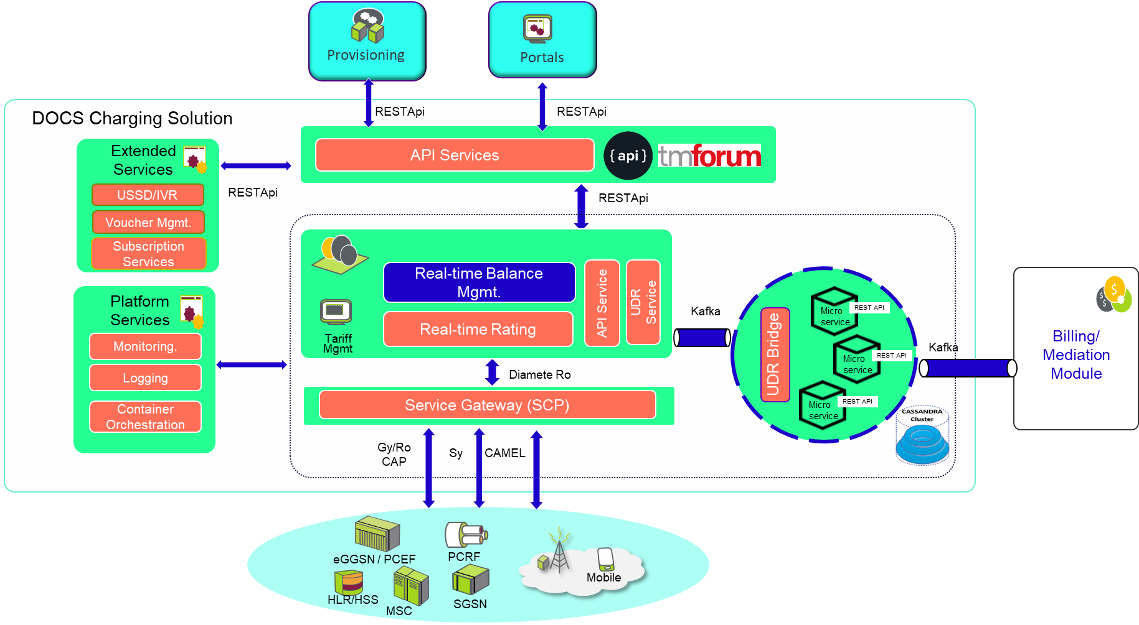

1. **Test Results**

