**TM Forum Open APIs**

**Conformance Certification**

*Company Name:* ***Tecnotree***

*TM Forum Open API Name:*

***Payment Management API – TMF 676***

*TM Forum Open API Release Version:* ***20.5 /4.0***

**Report Date: 4th September 2021**

1. **What Product or Solution does your API support?**

There is a broad agreement in the Communication Services Provider (CSP) community that one of the largest contributors to customer retention, and thereby solid revenue, is the customer experience. At the same time, research has identified that this hallmark of greater customer experience can be directly linked to efficiency in Billing. This view is derived from the simple fact that a bill is the most visible communication between a customer and the CSP. Even today a large majority of customer care interactions continue to revolve around issues emanating out of incorrect billing.

Given the importance of accurate billing, one of the first priorities towards an improved customer experience is to address the pressing needs around seemingly mundane issues like billing operations and revenue assurance, thereby removing the source of customer dissatisfaction which is stemming customer churn to avoid reduction in revenue.

The situation is soon becoming complicated for the CSPs facing a double-sided threat endangering their quest for new revenue. On one hand, they are faced with the visible dangers of being non-competitive due to an inability to quickly monetize new services. This coupled with the more traditional challenges in billing operations effectiveness is casting serious doubts on their ability to create an outstanding customer experience which in extreme cases will compromise their ability to retain customers. The first of these challenges is directly linked to the limitations of many legacy billing solutions, slowing down the introduction of new offerings and hence immediate revenue growth. The second of these challenges is forcing CSPs to have another look at new ways to consolidate and manage their core billing operations in order to keep operational costs down.

A careful analysis around the above demands clearly presents an array of opportunities revolving around the support of multiple services, efficient charging and billing, bill convergence and flexible payment options. By carefully balancing the operational efficiencies with new business model introduction a CSP can quickly tap into new revenue streams while all the while ensuring integrity of the related business processes. Tecnotree **Digital Convergent Billing System (DCBS)** is a unified revenue management solution that can help to consolidate the various business assets and transform them into reusable components for creating new business models to address the growing consumer appetite for new services. Designed to address all the revenue management needs of a modern CSP, Tecnotree Digital Convergent Billing System provides an all-in-one convergent platform to manage traditional as well as next-gen services, it helps CSPs to maintain a holistic view of all services subscribed and used by the customers in order to create novel ways for service monetization.

Tecnotree Digital Convergent Billing System (**DCBS**) allows CSPs to conveniently manage a mix of multiple services from themselves and partners alike. By providing a real-time charging capability Tecnotree Digital Convergent Billing System ensures accurate billing every time while supporting a broad range of flexible payment options. By monetizing all customers across business lines and types of service on a single platform the CSPs can rationalize the often-inefficient legacy interfaces previously in place across various network elements, significantly reducing the possibility of revenue leakage and resulting bad debts. All the above put together allows CSPs to concentrate on running a business rather than worrying about maintaining their billing infrastructure. Further customer experience is improved by allowing the choice of a single bill for all services, along with access to accurate real-time information over self-care.

1. **Overview of Certified API**

By definition of TMF 676, The Payments API provides the standardized client interface to Payment Systems for notifying about performed payments or refunds. Examples of Payment API originators (clients) include Web servers, mobile app servers, Contact center dashboards or retail store systems.

In Tecnotree DCBS, the Collections module is used to track all the financial transactions and to post the transactions to an external accounting system.

Payments can be collected from the Subscribers against invoice or purchase of items and services and from the Dealers against purchase of items and services.

The different payment modes supported are outlined below:

Table 1 Supported Payment Modes - Sample

|  |  |  |  |
| --- | --- | --- | --- |
| Payment Mode | Accepted from Subscriber | Accepted from Dealer | Additional Information |
| Cash | Yes | Yes |  |
| Cheque | Yes | Yes |  |
| Debit Card | Yes | Yes |  |
| Credit Card | Yes | Yes |  |
| Payment at Bank in cash |  | Yes | Dealer pays cash at the CSP’s bank account, obtains a receipt from the bank, and presents it to the CSP as proof of payment. |
| Payment in Bank by cheque |  | Yes | Dealer pays by cheque at the CSP’s bank account, obtains a receipt from the bank, and presents it to the CSP as proof of payment. |
| Direct debit | Yes |  | Subscribers can give standing instruction to bank to settle monthly bills. Based on the subscriber billed amount, bank sends upload file to be updated to subscriber accounts. |
| Internal Loyalty Voucher | Yes | Yes | Subscribers can make a payment against the invoices using the internal (issued by the CSP) loyalty voucher. |
| External (Third  party voucher) | Yes | Yes | Subscribers can make a payment against the invoices using an external (third-party) loyalty voucher. |
| ATM | Yes | Yes | Subscriber can make payment against invoices using ATM. |

As illustrated in the diagram below CSP user can effectively manage payment collections, cheque management, payment transfers and refunds and generation of feed to GL systems.

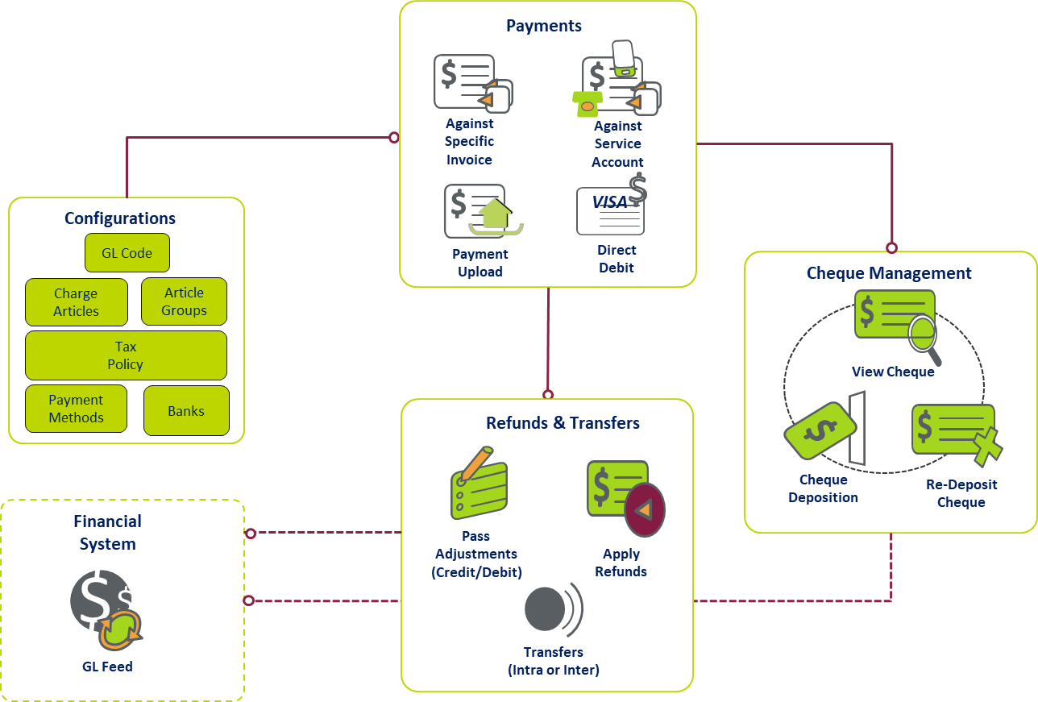

Figure 1 Financial Management Overview

1. **Architectural View**

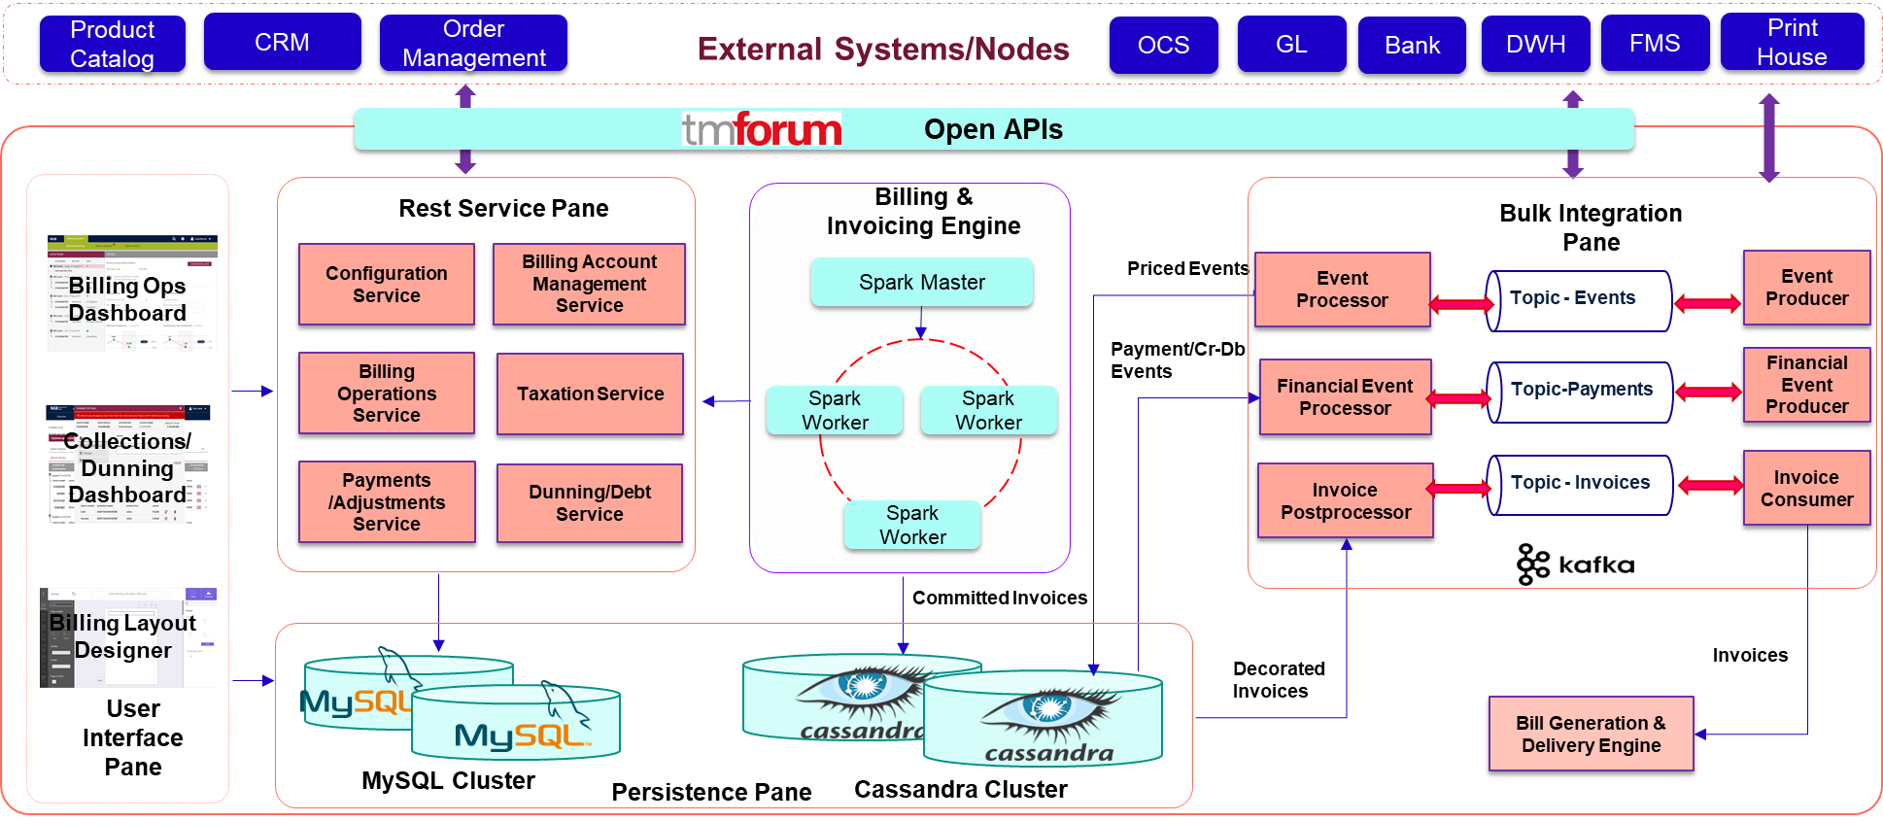

Figure 2 DCBS Architecture View

1. **Test Results**

