**TM Forum Open APIs**

**Conformance Certification**

*Company Name:* ***Liberty Wireless Pte Ltd (Circles.life)***

*TM Forum Open API Name:*

***Customer Management - TMF629***

*TM Forum Open API Release Version:* ***19.0 / v4.0***

**Report Date: 01/09/21**

1. **What Product or Solution does your API support?**

The test was done against our SaaS product Circles-X. Specifically the interface which handles customer management

1. **Overview of Certified API**

The Customer Management API handles critical business operations involving the customers and their data

1. **Architectural View**

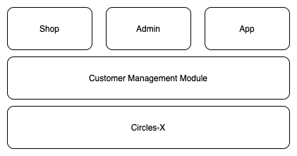

1. **Test Results**

