TM Forum Open APIs
Conformance Certification

Company Name: Inspur Technologies Co. Ltd

TM Forum Open API Name:
Resource Catalog Management API - TMF634

TM Forum Open API Release Version: 21.0 / 4.1

Report Date: 25-10-2021

- What Product or Solution does your API support?

Inspur IM Support to collect network resources by integrating with U2000. User can define the rule to collect data, and check tasks to ensure the resource data consistency and integrity.
Besides, IM also provide report configuration management function to define reports.
- Inventory Management Service
IM manages different resources in fixed network, such as space, access resource, number resource, access service.
- Resource Service
To support fixed network service provision. CRM can query resource coverage based on standard address by the services provided by IM. OSS can do service provision based on the resource assigned by IM.

IM detail architecture function are shown as follow:

- space Resource Management
- Number Resource Management
- Physical Resource Management
- Access Resource Management
- Cable Resource

- Overview of Certified API
Operations on Service: List individuals, Retrieve individual, Create individual, Patch individual, Delete individual.

- Architectural View

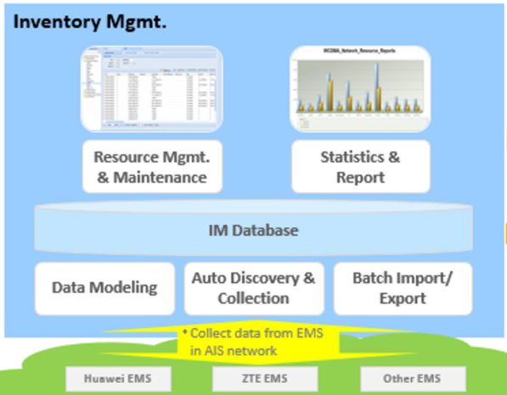

- Test Results

