s
TM Forum Open APIs
Conformance Certification

Company Name: Amdocs

TM Forum Open API Name:
TMF637 – Product Inventory Management

TM Forum Open API Release Version: 19.0/v4.0

Report Date: 19/Oct/2021

- What Product or Solution does your API support?

CES21 is Amdocs’ the latest evolution of its cloud-native, microservices-based, open and modular BSS-OSS integrated suite. The 5G-native CES21 enables service providers to build, deliver and monetize advanced services, leveraging their investments in technologies such as 5G standalone network, multi-access edge computing (MEC), software-defined networks (SDN), AI and machine learning (ML), and the cloud. The 5G-native suite delivers full flexibility to define your transformation strategy and modernization path based on your business priorities.

Amdocs CES21 includes digital care and commerce for multichannel commerce and care; a centralized catalog for flexible, marketing-driven service packaging spanning commerce, charging, partners and network, allowing service providers to quickly and easily define advanced services such as 5G standalone services and provide complex offering bundles such as multi-play, hybrid service provider/partner offerings, and a monetization suite for capturing revenue from traditional connectivity services as well as new digital, 5G, IoT and enterprise services. The monetization suite supports new business models and is built for maximum flexibility through partner lifecycle management, real-time billing, carrier or subscription billing and 5G convergent policy and charging Control (PCC), including new network data analytics function (NWDAF) and network exposure function (NEF). CES21 also includes end-to-end service lifecycle management capabilities covering service design, service orchestration, inventory management and assurance from the Amdocs Service and Network Automation solution.

CES21, includes embedded and productized analytics capabilities across the entire portfolio, from 5G network functions (NWDAF), to service automation and monetization, and care and commerce. These new intelligent analysis and automation capabilities will enable service providers to better launch, manage and monetize innovative new services in the new network era of 5G and cloud, where the wider range of use cases and telemetry data, and significant new operations complexity, are far beyond human scale to manage.

Aligned with TM Forum’s open API framework, CES21 offers a continuous integration/continuous delivery (CI/CD) environment built on Amdocs’ cloud-agnostic Microservices foundation (MS360). This helps service providers drive operational change and bring the business the needed agility and IT velocity to deliver results.

Amdocs Commerce & Care suite is a telco-specific cloud-native open and modular digital enablement platform for customer end-to-end care, commerce and order management journeys, spanning the entire order lifecycle, serving all care-billing-commerce needs with a single solution. It provides communications and media companies with the business agility to offer new digital experiences of the type and at the pace of native internet companies across ANY channel application, assisted or unassisted, existing or future ones; supports ANY line of business, service and bundle including third party - to ANY customer, existing or new, consumer or enterprise and it fits any existing legacy BSS that the operator is using.

The suite includes Amdocs’ Experience360, low/no code foundation, allowing an easy drag & drop-based fast and flexible business-led configuration of new experiences, flows, views and permissions to determine best CX to ensure each engagement is handled with the best course of action and optimal customer experience.
The Amdocs Commerce & Care Suite is cloud-native, so it can scale on-demand to support changing activity levels. Furthermore, it incorporates open-source technologies and exposes application programming interfaces (APIs) that align with TM Forum standards, allowing easy addition of new capabilities and their re-use across any engagement channel, line of business and technology.

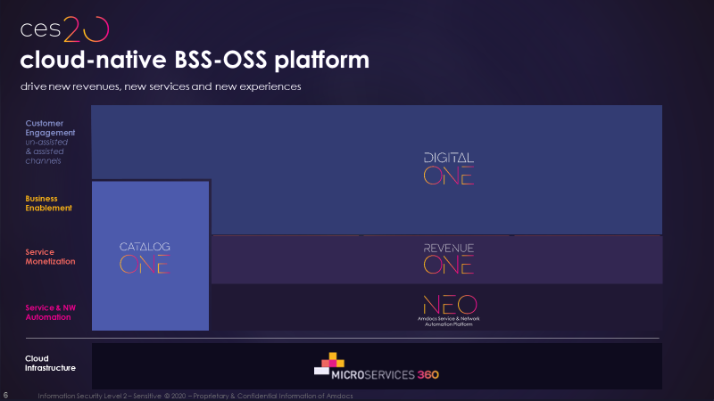

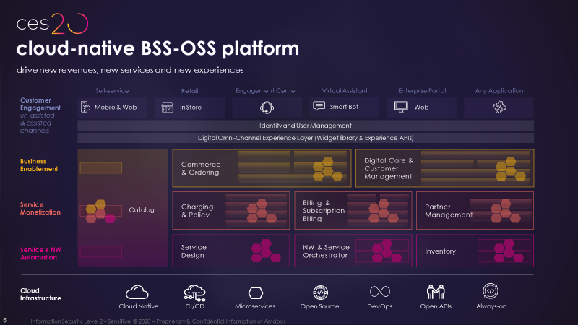
- Overview of Certified API

The Product Inventory Management API exposes the repository for product inventory items assigned to the customer.

The Product entity in Product Inventory Management represents an ordered product offering items defined in Product Catalog (i.e. product offering, product specification, product price). During product order handling the Product Inventory Management creates a product entity for each product included in the product order. Each product inventory item maintains a reference to product order / product order item information, price and promotion information, customer information and relations between inventory products.

The Product Inventory Management API enables consumers to maintain a history of product inventory versions owned by their customers. The Product Inventory Management API provides a set of capabilities used by consumers, such as retrieving customer inventory product details and updating existing product inventory (by submitting modification orders such as modify, suspend, resume, and terminate orders).

Prior to persisting the data, Product Inventory Management performs a range of activities that validate the Product Inventory, such as validating product configurations, validating whether a product can transition to its next product status, validating the existence of a customer, and validating the existence of a paying entity.

- Architectural View

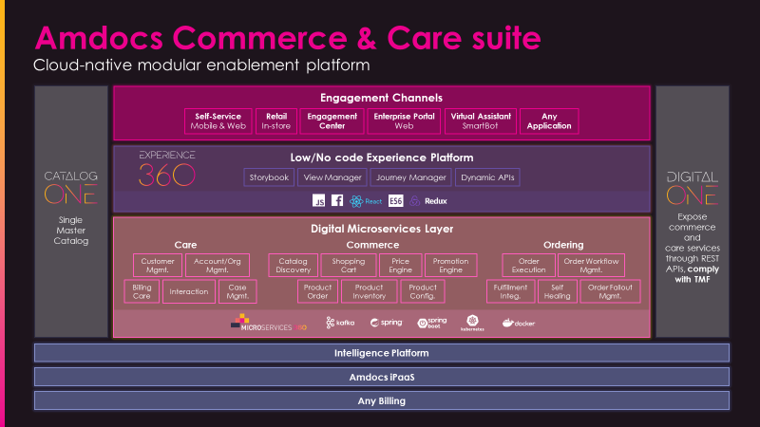

- Test Results

