**TM Forum Open APIs**

**Conformance Certification**

*Company Name:* ***Tecnotree***

*TM Forum Open API Name:*

***Customer Bill Management API – TMF 678***

*TM Forum Open API Release Version:* ***20.5 / 4.0***

**Report Date: 19th October 2021**

1. **What Product or Solution does your API support?**

There is a broad agreement in the Communication Services Provider (CSP) community that one of the largest contributors to customer retention, and thereby solid revenue, is the customer experience. At the same time, research has identified that this hallmark of greater customer experience can be directly linked to efficiency in Billing. This view is derived from the simple fact that a bill is the most visible communication between a customer and the CSP. Even today a large majority of customer care interactions continue to revolve around issues emanating out of incorrect billing.

Given the importance of accurate billing, one of the first priorities towards an improved customer experience is to address the pressing needs around seemingly mundane issues like billing operations and revenue assurance, thereby removing the source of customer dissatisfaction which is stemming customer churn to avoid reduction in revenue.

The situation is soon becoming complicated for the CSPs facing a double-sided threat endangering their quest for new revenue. On one hand, they are faced with the visible dangers of being non-competitive due to an inability to quickly monetize new services. This coupled with the more traditional challenges in billing operations effectiveness is casting serious doubts on their ability to create an outstanding customer experience which in extreme cases will compromise their ability to retain customers. The first of these challenges is directly linked to the limitations of many legacy billing solutions, slowing down the introduction of new offerings and hence immediate revenue growth. The second of these challenges is forcing CSPs to have another look at new ways to consolidate and manage their core billing operations in order to keep operational costs down.

A careful analysis around the above demands clearly presents an array of opportunities revolving around the support of multiple services, efficient charging and billing, bill convergence and flexible payment options. By carefully balancing the operational efficiencies with new business model introduction a CSP can quickly tap into new revenue streams while all the while ensuring integrity of the related business processes. Tecnotree **Digital Convergent Billing System (DCBS)** is a unified revenue management solution that can help to consolidate the various business assets and transform them into reusable components for creating new business models to address the growing consumer appetite for new services. Designed to address all the revenue management needs of a modern CSP, Tecnotree Digital Convergent Billing System provides an all-in-one convergent platform to manage traditional as well as next-gen services, it helps CSPs to maintain a holistic view of all services subscribed and used by the customers in order to create novel ways for service monetization.

Tecnotree Digital Convergent Billing System (**DCBS**) allows CSPs to conveniently manage a mix of multiple services from themselves and partners alike. By providing a real-time charging capability Tecnotree Digital Convergent Billing System ensures accurate billing every time while supporting a broad range of flexible payment options. By monetizing all customers across business lines and types of service on a single platform the CSPs can rationalize the often-inefficient legacy interfaces previously in place across various network elements, significantly reducing the possibility of revenue leakage and resulting bad debts. All the above put together allows CSPs to concentrate on running a business rather than worrying about maintaining their billing infrastructure. Further customer experience is improved by allowing the choice of a single bill for all services, along with access to accurate real-time information over self-care.

1. **Overview of Certified API**

Digital Convergent Billing provides CSP’s with an enhanced Billing Operation Dashboard User Interface (UI). The UI allows end-user to create, schedule, execute and monitor multiple bill runs in a clear, consistent & simple manner, aiding in prioritising actions.

The dashboard provides capability to schedule/reschedule, monitor bill run status, view quality assurance (QA) and analysis of bill run revenue & performance information, search and retrieve customer bill/s.

The staged and level based presentation of information provides end-user a greater degree of visibility. Search capability allows end-user to easily filter & locate bill run information using a range of filter criteria.

The *figure* below depicts the landing page of Billing Operations Dashboard:

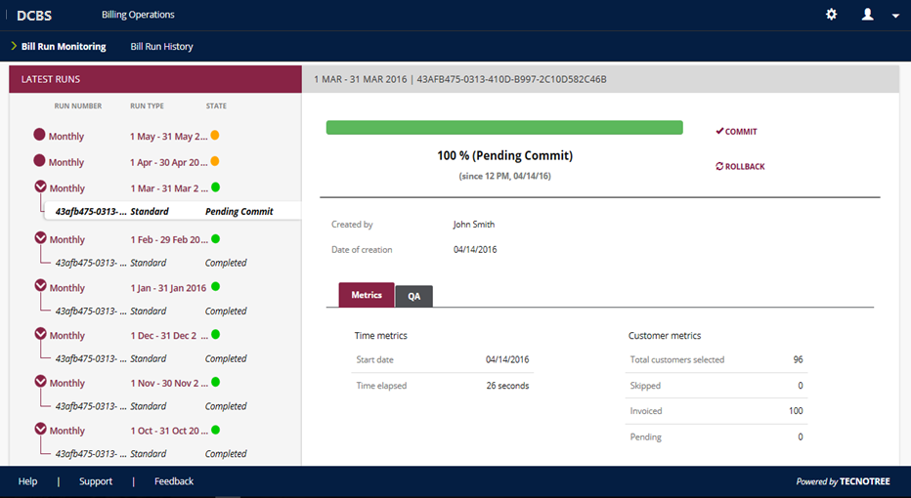

Figure 1 Billing Operations Dashboard

In order to simplify access control based on roles, the Convergent Billing administrator can configure access to specific areas/functions of dashboard as described below.

*Table 1 Billing Operations user profiles and description*

| **Billing Manager** | A Billing Manager user is responsible for creating new bill runs, configuring the Stage Workflows, defining Tasks & Criteria & Notifications on Success/Failure. In addition this user profile can also view billing run analysis view. |
| --- | --- |
| **Billing Operatives** | This user type is allowed to Execute, Monitor, Perform QA checks for a Bill Run. They usually report to the Billing Manager. |
| **IT Operatives** | Apart from the Billing Group users, IT users also play a supporting role in Bill Run. They typically create supporting system scripts to validate data and are attached to various Task/s linked to Pre/Post Bill Check Stage. These scripts are created outside the UI. |

Tecnotree DCBS exposes Rest based TM Forum Open APIs for integration towards external Applications. The mode of operation is either Synchronous or Asynchronous depending on the operation. The below screenshots illustrates a sample of Rest APIs exposed by Digital Convergent Billing.

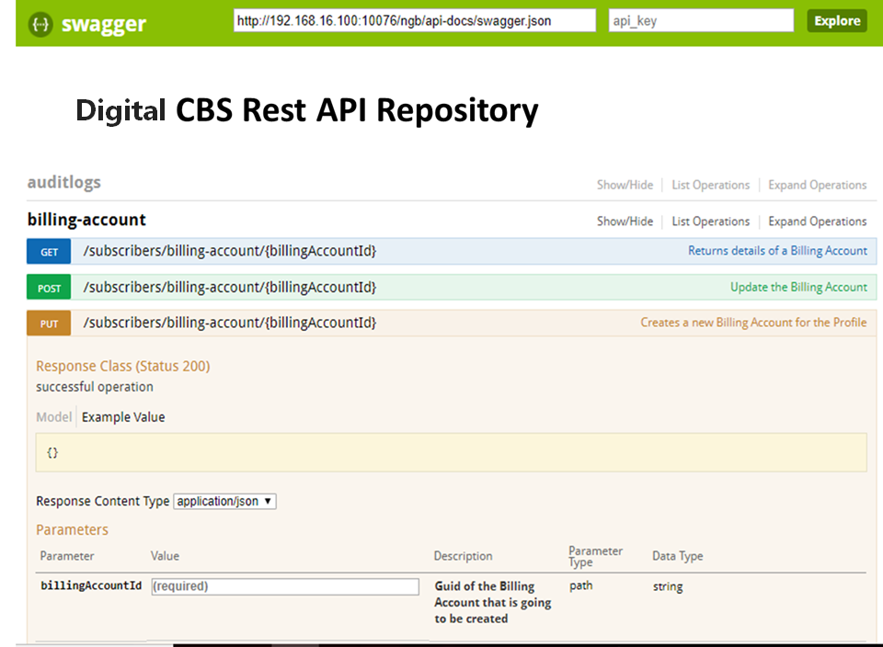

Figure 2 DCBS Rest API repository

1. **Architectural View**

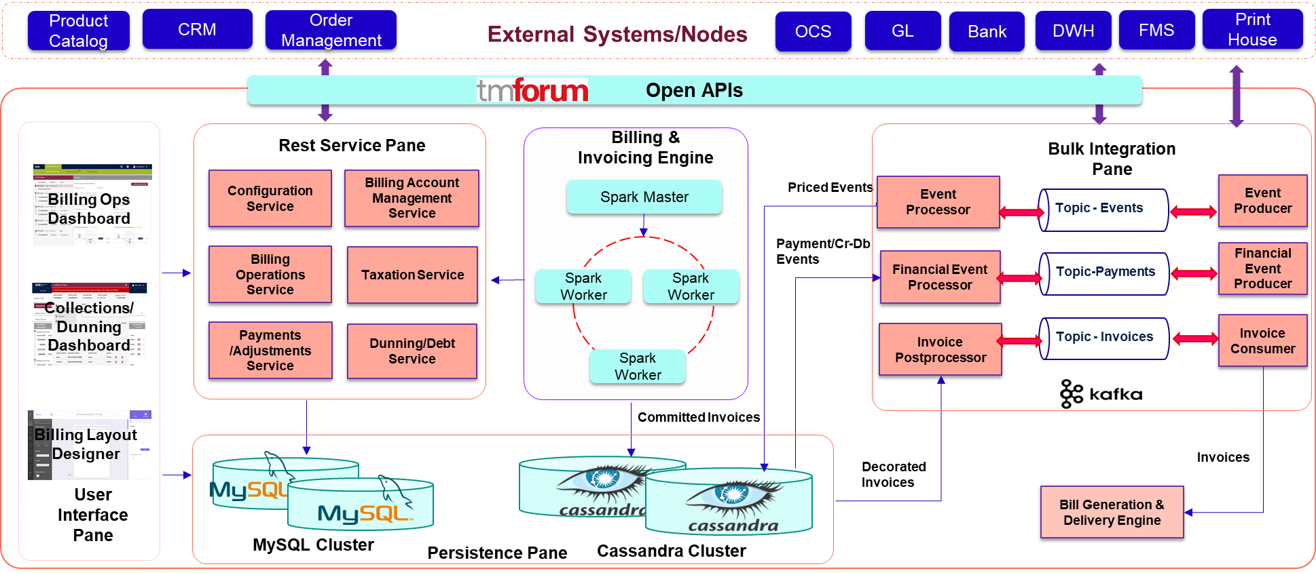

Figure 3 DCBS Architecture View

1. **Test Results**

