**TM Forum Open APIs**

**Conformance Certification**

*Company Name:* ***Tecnotree***

*TM Forum Open API Name:*

***Geographic Site Management API***

*TM Forum Open API Release Version:* ***20.5 / 4.0***

**Report Date: 19th October 2021**

1. **What Product or Solution does your API support?**

Tecnotree Digital Accelerator platform powered by Microservices based architecture and acts as a comprehensive fulfilment tool that enables DSP to address the growing consumer appetite for services across the spectrum. Below listed are the modules of Digital Accelerator Platform: -

* **Digital API Manager** (API Gateway and Digital Integration Accelerator): Digital API Manager is bifurcated into two components i.e. API Gateway and Digital Integration Accelerator to act as a Single-Entry point supporting REST and Non REST based API communications.
* **Orchestrator**: Orchestrator provides a workflow engine for Microservices orchestration. Orchestrator ensures that once started, flows are always carried out fully, retrying steps in case of failures. Along the way, Orchestrator maintains a complete audit log so that the progress of flows can be monitored. Orchestrator is fault tolerant and scales seamlessly to handle growing transaction volumes.
* **Platform Services**: Operations Platform provides a common runtime environment for all Tecnotree applications. It is the operation, administration and maintenance (OA&M) subsystem.

1. **Overview of Certified API**

Tecnotree’s Digital Accelerator Platform (DAP) provides a Rest based Open API for the geographic site management. The API can be used for creating, updating or retrieving geographic site which can be either associated to an account, profile or any other entity. This is referred as a common object within the solution and can be used by various application for Geographic location or address need.

This API allows the following operations:

* Create a new site
* Partial update of a geographic site
* Retrieve a list of sites stored in a server filtered by a given criteria
* Retrieve a specific site
* Notification of events on a geographic site
  + geographic site creation
  + geographic site removal
  + geographic site status change
  + geographic site value change used to notify that any data in a geographic site has just changed

1. **Architectural View**

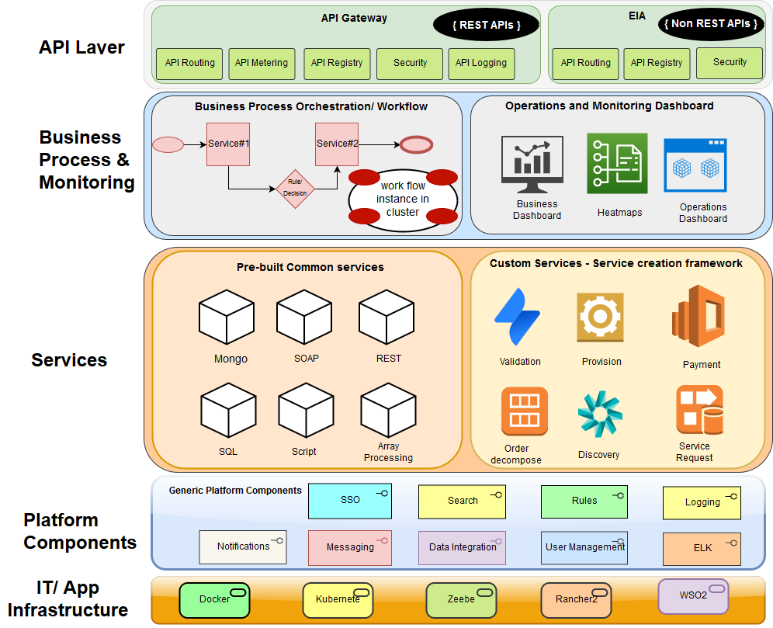

1. **Test Results**

