**TM Forum Open APIs**

**Conformance Certification**

*Company Name:* ***Tecnotree***

*TM Forum Open API Name:*

***TMF634 - Resource Catalog Management API***

*TM Forum Open API Release Version:* ***R 21.0 / 4.1***

**Report Date: 08th November 2021**

1. **What Product or Solution does your API support?**

Market opportunities and evolving customer needs have encouraged Communication Service Providers (CSP) in broadening their operations and managing multiple lines of businesses (LOBs). Such expansions have compounded the complexity of their products and services and resulted into multiple OSS and BSS systems in their operational landscapes. At the same time, there is an intense pressure of enhancing customer experience and declining traditional revenue streams.

Tecnotree Digital Catalog Manager (DCM) is a central repository of products that spans across multiple lines of businesses. DCM plays a vital role in CSP’s environment by providing the integration of products and resources across the business and operational support systems (B/OSS), thus contributing to both the current and emerging market opportunities by helping them surge ahead of the competition.

Tecnotree Digital Catalog Manager (DCM) helps unify product management and streamlines the process of product creation and launch. It provides CSPs the flexibility of phasing out legacy systems and migrating to strategic systems to meet their product management challenges. This comprehensive and detailed approach adopted by DCM is one of the core reasons for it becoming the tool that bolsters the CSPs’ business and operational strategy.

1. **Overview of Certified API**

Resource Catalog is a collection of resource category, which are aggregated through logical groups called resource candidates containing resource specifications. DCM provides Open APIs/REST Based APIs in line with TM Forum defined specification that allows management of the entire lifecycle of the Resource elements.

1. **Architectural View**

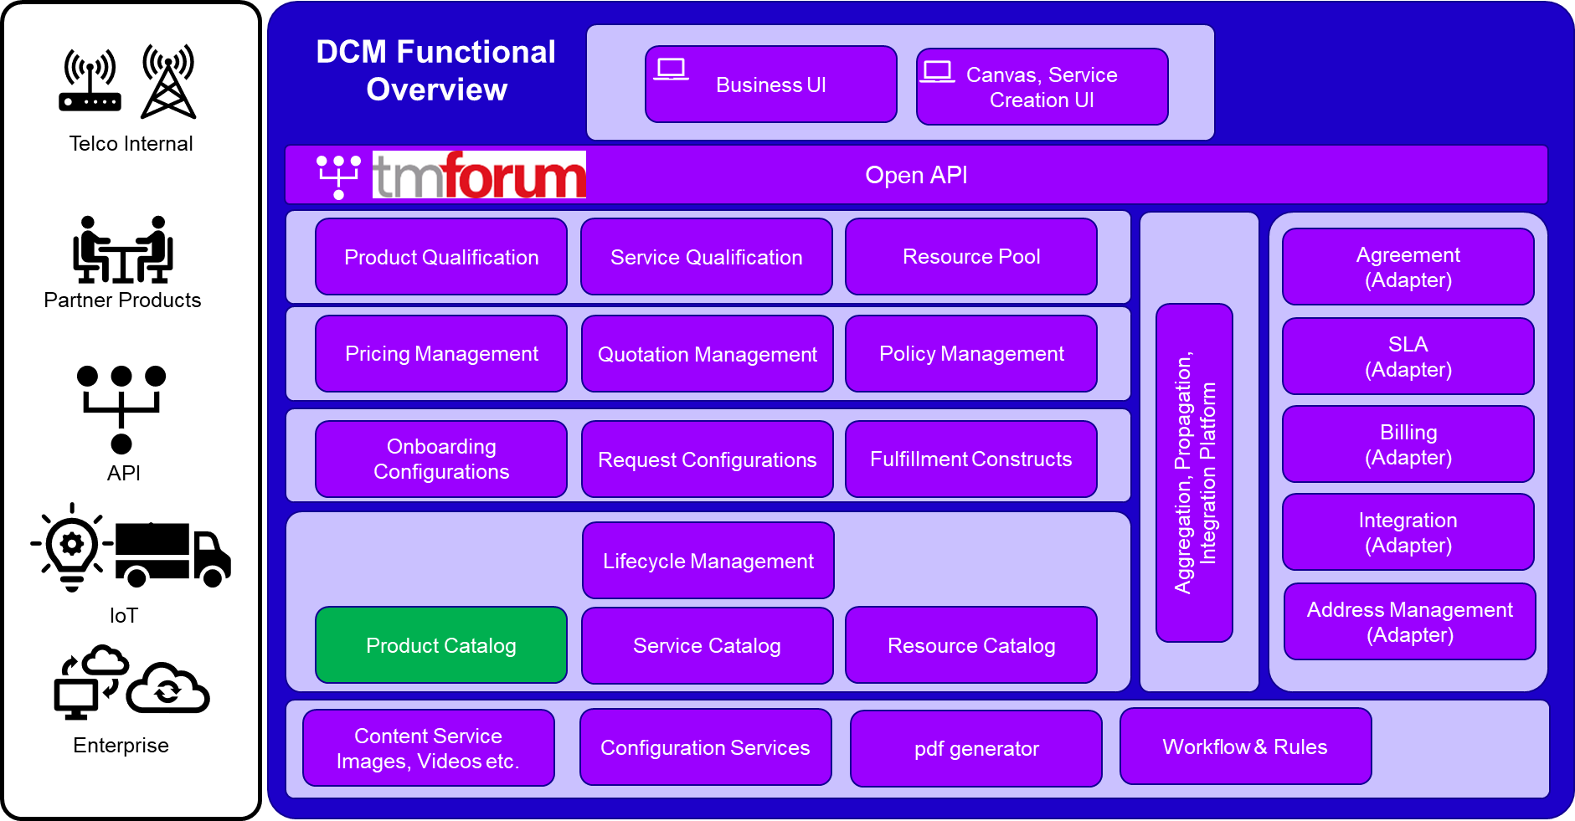

1. **Test Results**

